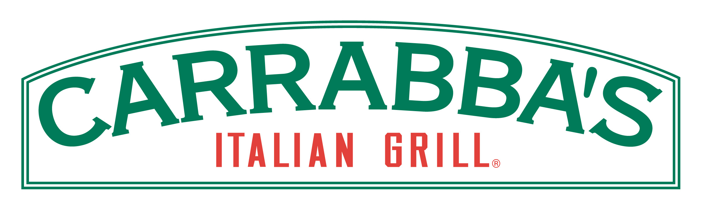

Incentives For Highest Sales:

The Top Sellers
(one Student for each group)
will receive…

TWO Free Dinners!

One Winner from Grades K-2
One Winner from Grades 3-5

Class Prize:

The Top Selling Class of the entire school will be given a…

PIZZA PARTY!!

Watch for Updates on the Morning Show During the Next Two Weeks!

