Library News ~~ Summer 2015 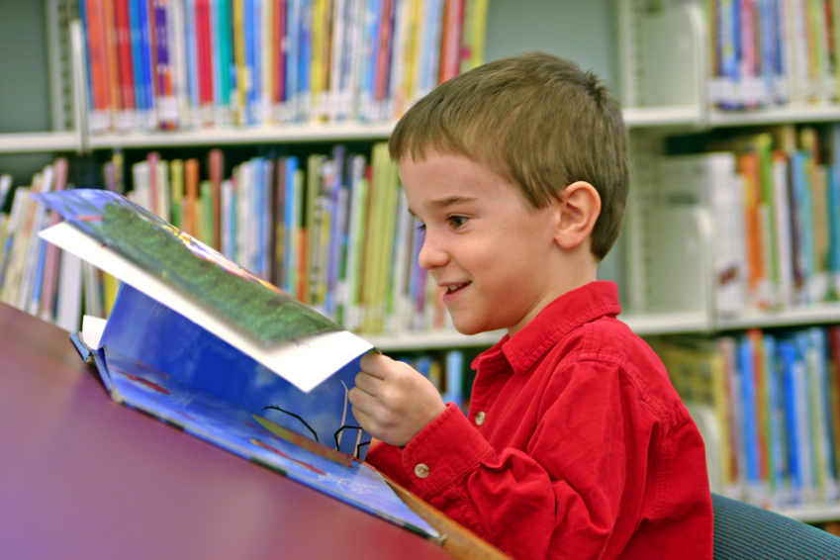
Knowledge is free at the Library. Just bring your own container. container.
Spring is here and Summer is around the corner! We all know summer can be filled with many fun activities, family trips, time to relax, and adventures beyond the normal school day. Did you also know that summer can also be a time when students experience the Summer Slide. This slide refers to the drop in a student’s reading level over the summer and the loss of many reading skills and strategies learned over the school year. This happens when a student doesn’t read over the summer. Research has proven that this is a serious problem when kids don’t read over the summer.
Because we don’t want our Hazelwood students to experience the Summer Slide, here are some great opportunities to keep your child focused on reading:
- Students can also come to the Hazelwood Summer Reading program. The library will be open for book checkout every Tuesday starting on June 23rd and ending on August 4th. It will be open from 11am to 1pm. Storytime will happen from 11:30-12:00 with a special guest reader each week.
- Enter the Barnes and Noble Summer Reading Challenge. Information went home with your child about this program during the week of June 8th. If you need more information contact me at cclarke@haywood.k12.nc.us. If a student fills out a reading log for 8 books with a 1-2 sentence recommendation, they can hand it in to Barnes and Noble in Asheville and pick a free book from a selected list of GREAT books!
- The Haywood County Public Library will also be having a Summer Reading program called “Make a Splash - Read”. Click on this website for more information: http://www.haywoodnc.net/index.php?option=com_content&view=article&id=913:pio-summer-reading-0610&catid=57:Info&Itemid=194

Have you ever wondered what book to read next after you finished a wonderful one? Here are some websites you and your student can use for books recommendations. A great place to find books for great reading all summer long:

www.abookandahug.com
www.readkiddoread.com
Wishing you a wonderful summer filled with great adventures and great reading!
See you at the library!


