Welcome Back!!! We are very excited about what is happening at Hazelwood this school year, especially in Physical Education class. This year 3rd-5th grades will be participating in a Sport Education curriculum designed uncover each students leading potential. Each team will have a few different roles. Each student will have a specific role on their team. Students will stay on the same team each week until the unit is over. At the end of the unit, one team will be named Unit Champion. Teams will score points based on team quizzes, daily competitions, and a teamwork score given each class. Each unit students will get a new role and a new team. Through the use of this curriculum we hope students will realize the importance of leadership to any group and how anyone can be a leader, even when not the captain.

**Plott Hound P.E Fall 2013 Newsletter**

Kindergarten-2nd grade students will begin learning the 8 basic locomotor skills.

Walking, Running, Skipping, Hoping, Leaping, Jumping, Side-Sliding, Galloping

Please help your student practice these at home! We then will begin practicing pairing these with other skills like catching, throwing, striking, and kicking. Students will quickly gain good base of skills, so that when they move to the upper grades they already have the necessary knowledge to succeed in Physical Education!

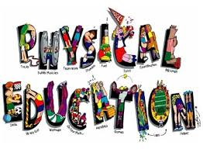

**Virtual PE**

Haywood County Schools allowed us to begin using Virtual PE to assess students in third through fifth grades. Virtual PE is a great way to ensure all students are able to perform skills at a high level. Toward the end of the first 9 weeks, parents will be getting a PE progress report that informs you of how your student is doing in PE. Repetition is the best way for students to become better at any skill. Please help your child practice at home! If you have any questions about virtual PE feel free to email

Mr. Conard.

