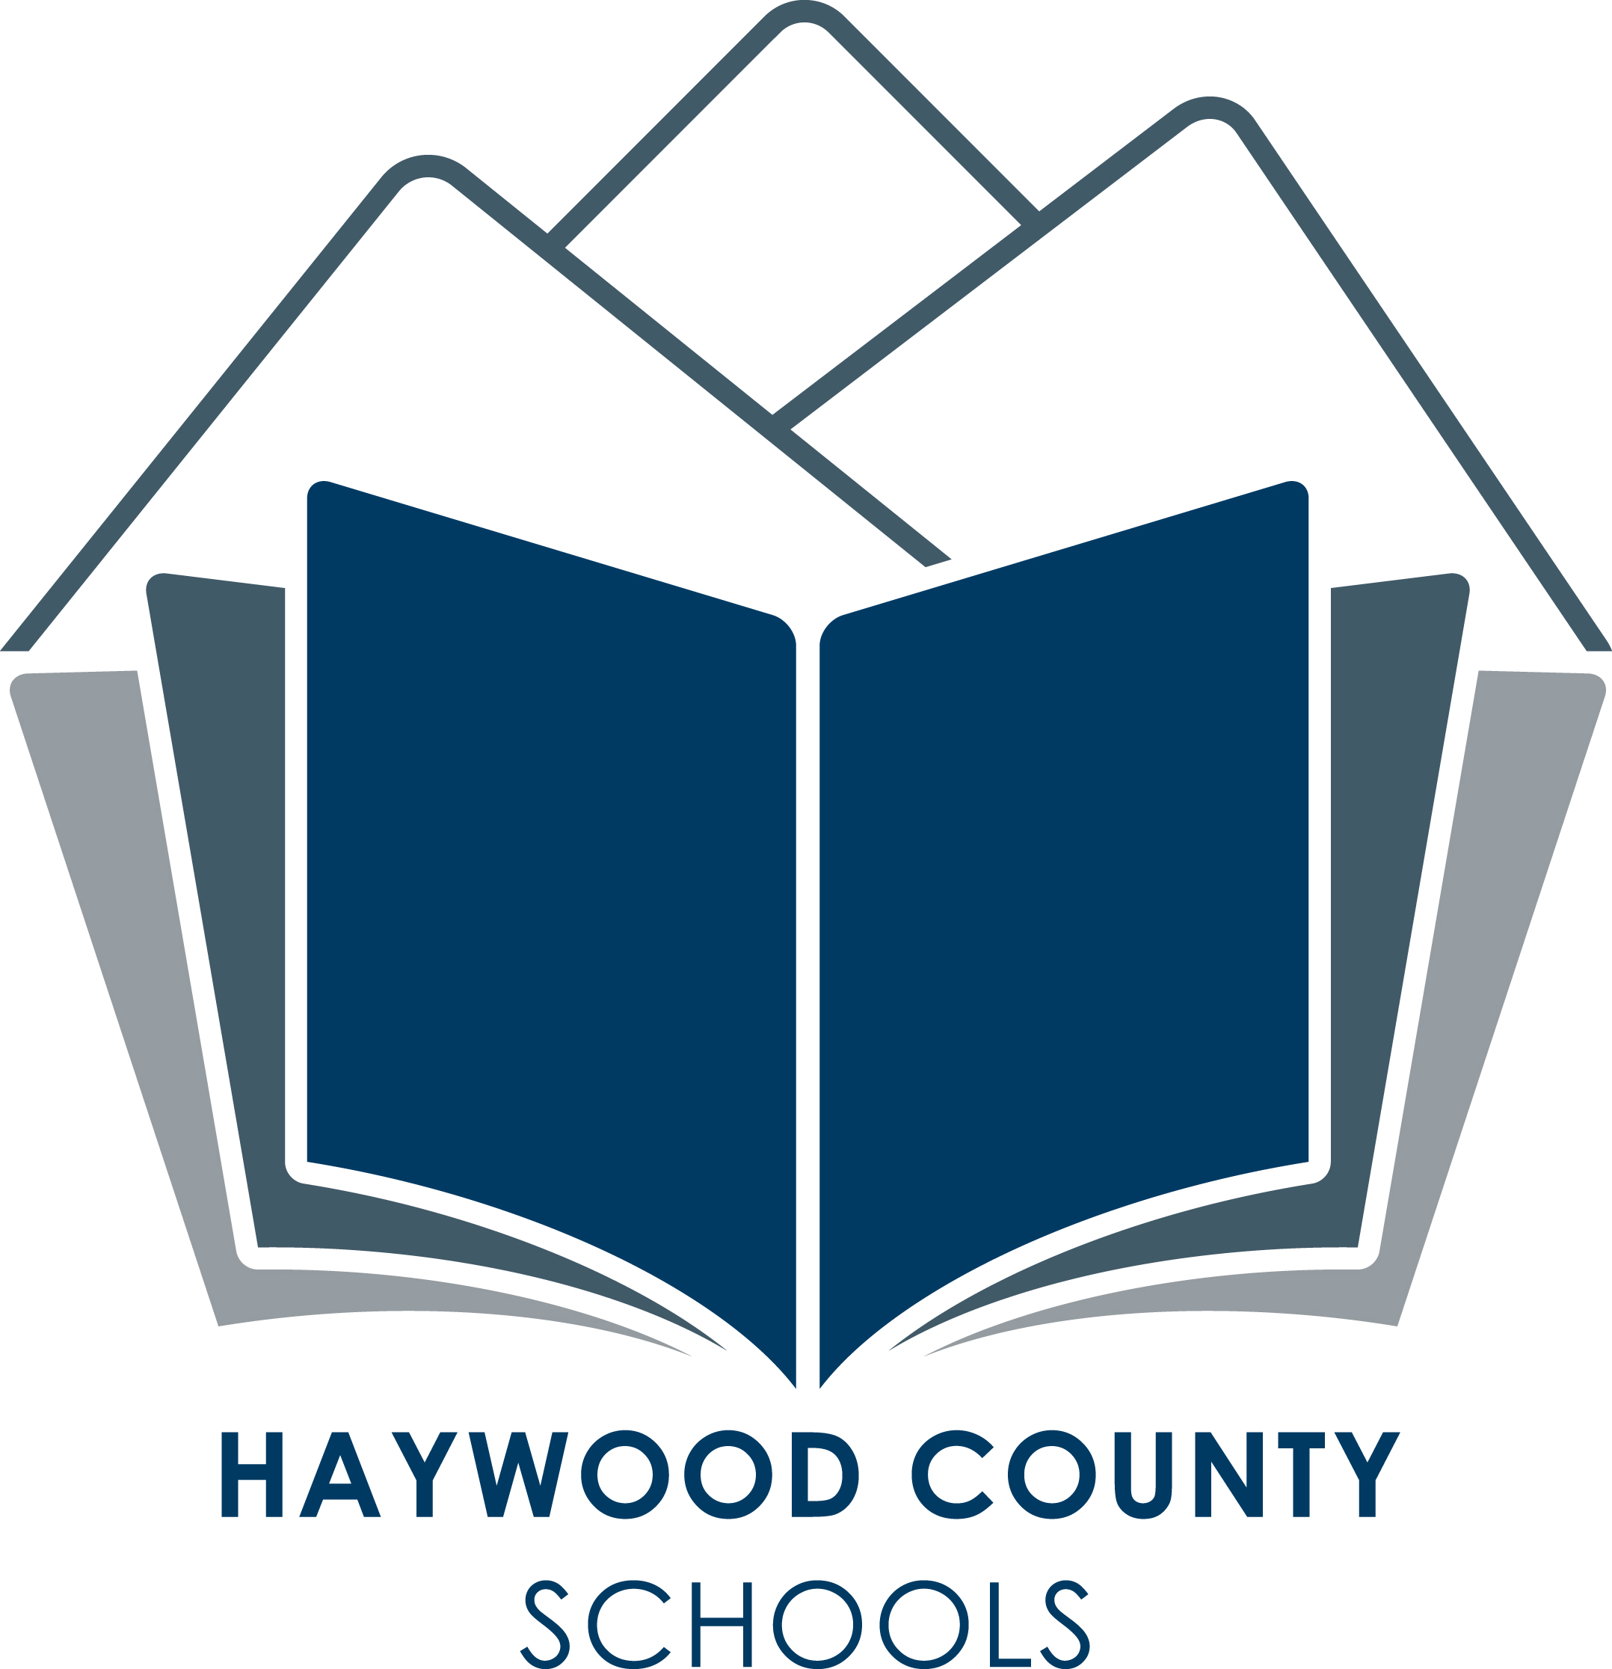
Haywood County Schools
1230 North Main Street

Waynesville, NC 28786
828 456 2400

Board of Education
Charles H. Francis, Chairman; Jim Harley Francis, Vice-Chair;
Larry Henson, Steven Kirkpatrick, Bobby Rogers, Jimmy Rogers,
Logan Nesbitt, Ronnie Clark, David Burnette

Important Information!!!!

Online Free and Reduced Applications for Haywood County Schools

Due to the Pandemic USDA has authorized free breakfast and lunch for all Children 18 and under. Although school meals are free to all students for the 2021-2022 school year, it is important to submit a free and reduced meal application if you think your family might qualify. It's more than a meal application. The percentage of students approved for free and reduced meals is used to ensure continued funding to support all students in our district through Title 1 and E-rate programs that provide supplemental funds to school districts to assist with meeting educational goals. If you feel your family may qualify, please go to www.lunchapplication.com and fill out an online application.
www.LunchApplication.com has been designed to make it easy for you to know exactly what information you need to provide and to guide you through the process. Once your application has been received, the district office will determine your eligibility and send you a letter with the results.
www.LunchApplication.com is an easy, secure, and convenient way to apply for free or reduced meals.

To apply, go to www.LunchApplication.com and Click Apply Now. Applications for the 21-22 School year cannot be submitted before July 1, 2021.

* If you do not have access to the internet, please ask the school office or call 828-627-1150 for a paper copy of this year's Free and Reduced Meal Application.

** If you have already received a letter telling you that your child was preapproved for meal benefits, you do not need to reapply. Please make sure all of the school-aged children living in your household are listed on the approval letter. If not, please get in touch with Sheila McClure @ 627-1150 or smcclure@haywood.k12.nc.us.

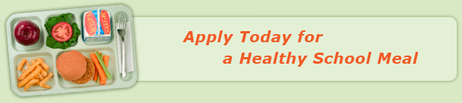

USDA is an equal opportunity employer and provider.

