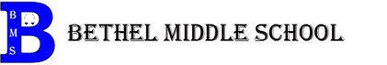
PTO Coffee Fundraiser

November 3, 2022

Re: PTO Coffee Fundraiser

Dear Parents,

Bethel Middle School PTO is hosting a coffee fundraiser in partnership with Dynamite Roasting Co. We will offer a variety of pre-ordered bagged coffees, K-Cups, and Ready-to-Pour Cold Brew. Each option is $16.00 each. All proceeds will benefit the Bethel Middle School PTO who provides support to our teachers and students.

- Unleaded Decaf coffee
- Daymaker Blend (Light/Dark blend) coffee
- WNCW Mountain Morning (Medium roast) coffee
- K-Cups Mountain Roast (Medium roast)
- Ready-to-Pour Cold Brew

Please pay with checks payable to Bethel Middle School PTO or cash and submit payment with the completed order form by November 21st, 2022.

Thank you for your continued support for Bethel Middle School!

Sincerely,
Bethel Middle School PTO

