***BETHEL PTO T-SHIRTS ORDER FORM***

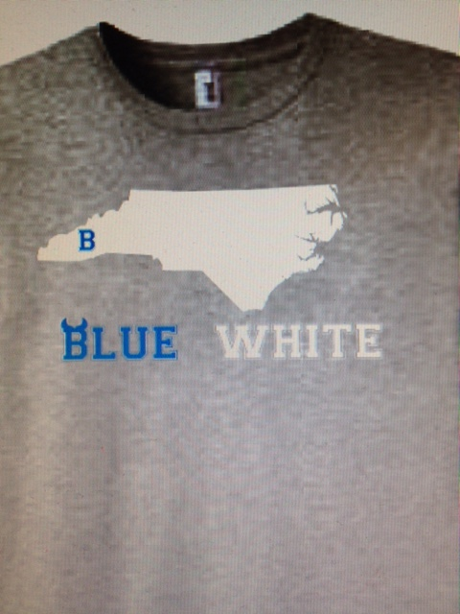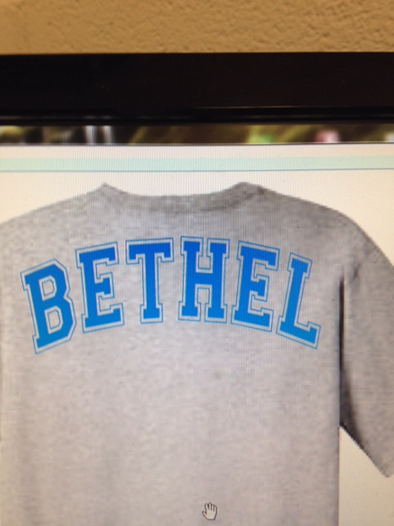

**Front Back**

|  |  |  |  |  |  |  |  |  |  |  |  |  |
| --- | --- | --- | --- | --- | --- | --- | --- | --- | --- | --- | --- | --- |
| **Name** | **Phone** | **Short Sleeve** | **Long Sleeve** | **S** | **M** | **L** | **1X** | **2X** | **3X** | **4X** | **Qty.** | **Amount** |
|  |  |  |  |  |  |  |  |  |  |  |  |  |
|  |  |  |  |  |  |  |  |  |  |  |  |  |
|  |  |  |  |  |  |  |  |  |  |  |  |  |
|  |  |  |  |  |  |  |  |  |  |  |  |  |
|  |  |  |  |  |  |  |  |  |  |  |  |  |

***Gray T-shirts with blue and white lettering***

***$10.00 for short sleeve and $15.00 for long sleeve***

***With additional 1.00 for 2X, $2.00 for 3X and $3.00 for 4X***

***Orders and payment must be received by Friday, April 15, 2016***

***Make checks payable to BMS PTO, retuned checks will have a $25.00 service fee***