PTO OCTOBER NEWSLETTER

Cookie Dough Reminders  Thank you to all who sold Cookie Dough. Our students and parents have once again done an awesome job! Our sales have exceeded last year's. All money is due in by October 7th. Please be sure all checks are made out to the Clyde PTO, and not to the Cookie Dough Co. Our Mega Party and Fall Festival will be held on Monday, October 12th. The Mega Party will be held during school hours and the Fall Festival will be held that evening from 5:00 – 8:00 pm.  We are still in need of volunteers. If you are able to help at any time, please send a note to school with your child stating what times you will be available. There is also a sign up sheet in the front office. Any time at all that you will be available will be greatly appreciated. We have as much as the children!  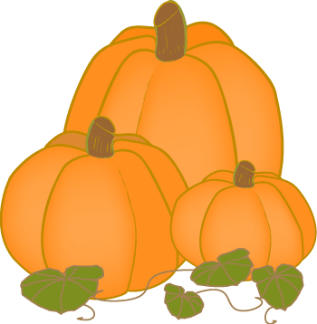 | Team Spirit!!!!!  The PTO will be selling Pisgah/Tuscola tattoos. Your child will able to purchase and have applied, the tattoo of his choice, every Friday, beginning October 2nd. This will be done throughout the football season. The cost of the tattoo will be $.50. There will be a table set up in the front lobby. Students may purchase their tattoo upon arrival in the mornings or at a time specified by their teacher. We look forward to seeing all of you Bear and Mountaineer fans!  Pumpkin Decorating Contest  Start decorating those pumpkins! We will have a table set up in the lobby for all of your scary,silly,and goofy creations. Lets see how creative you can be! You may start bringing in your pumpkins on Monday. It will be hard to top last years, so put on your thinking caps and get started. Judging will be held at the Fall Festival. 1st and 2nd place winners will receive a Wal Mart gift card. All other participants will receive a Wendy's coupon. | Fall Festival!!!!!  Fall Festival will be October 12th from 5:00 – 8:00pm. We have a fun packed evening planned; Inflatables, Games, Cake Walk, Silent Auction, Face & Hair Painting, 50/50 Raffle, Concessions and much more!! Please plan to come out with your family for this fun filled evening. Tickets will be available at the door for $.25 each.  We are asking all parents to send in a bag of wrapped candy to use for prizes at the Fall Festival. Please send it in with your child and we will pick it up from the classroom.  50/50 Raffle  We are sending 10 tickets home with your child to sell. If you should need more, send a note with your child to school. Tickets are $1.00 each. Please have all raffle money turned in by Friday, October 9th. Remind everyone that you do not need to be present to win. Tickets will also be available for purchase the night of the Fall Festival.

