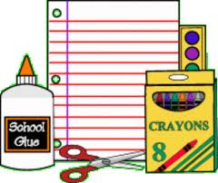

SUPPLY LIST for SECOND GRADE

Clyde Elementary 2023-2024

* Four wide-ruled spiral bound notebooks

(red-yellow-blue-green)

* One 4-pack fine tip BLACK EXPO low-odor dry erase markers
* Two boxes Crayola 24-count box of crayons
* Crayola 12-count box of colored pencils
* Two 12-pack Ticonderoga #2 pencils
* One 4-pack Elmer glue sticks
* One plastic pencil box
* One package pencil top erasers
* Kids Headphones or Kid Size Earbuds

**Please DO Not send:**

* Trapper Keeper
* 3-ring binder
* hand held pencil sharpener

**CLASSROOM Wish List (we would greatly appreciate any of these optional items)**

* **Boxes of tissues**
* **Clorox Disinfecting Wipes**
* **Lysol Spray**
* **Hand Sanitizer**
* **Ziploc Storage Gallon Bags **(not slider)**

😊THANK YOU SO MUCH 😊