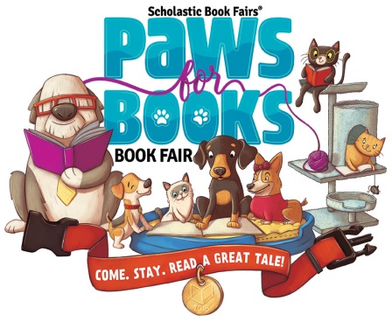

Book Fair is on the way!

Our theme this year is Paws for Books Book Fair: Come. Stay. Read A Great Tale! So make sure you stop by and find your very own treat at our Spring Book Fair from Monday 3/12/17- Friday 3/16/17 or check it out online at

http://www.scholastic.com/bf/clydeelementaryschool3

Book Fair Spirit Week:

**\*Monday– Book Fair Kick Off!**

Book fair opens today!! Let’s kickoff our Spring Fair celebrating Paws for Books by bringing in a stuffed animal to shop with! Anyone who brings a stuffed animal on our kickoff day can come to the library and enter their name for a chance to win a $10 gift certificate to the book fair. We will be drawing 3 lucky winners at 1:30pm!

**\*Tuesday– Family Night! 5:30pm-8:00pm**

Clyde Elementary will be hosting a Book Fair Family Night in conjunction to the Art Show and 4th grade music performance! Bring your families and come to the library! Starting at 5:30, we will be showing a movie and drawing for a few “candy and soda door prizes.” You will also have a chance to enter to win our family reading basket!

**\*Wednesday– Book Fair Book Drive!**

Today we will be holding our semi-annual Book Fair Book Drive! To better meet our school’s needs, we are working on expanding our library’s book collection, and we would love for you to be a part of this amazing undertaking! To participate all you need to do is bring in gently used, **hardcover** books that are age appropriate for our kindergarten through fifth graders. The books must not be more than ten years old, and cannot have tears, rips, stains or markings. Students who donate will receive one dollar off of their book fair purchase!! :)

**\*Thursday– Breakfast with Books! 7:30am-8:15am**

Come join us in the morning to check out our new selection of books and have some breakfast refreshments on us!

**\*Friday– Lunch With A Loved One!**

This day will be the last day to purchase Items from the book fair! Children are invited to bring their grandparents, aunts/uncles, parents and other loved ones to lunch in the library (at the children’s regularly-scheduled lunch time). Loved ones may bring a brown bag lunch or buy from the cafeteria, and bring to the library. After lunch they are welcome to shop the book fair, browse and have their picture taken in our photo booth!