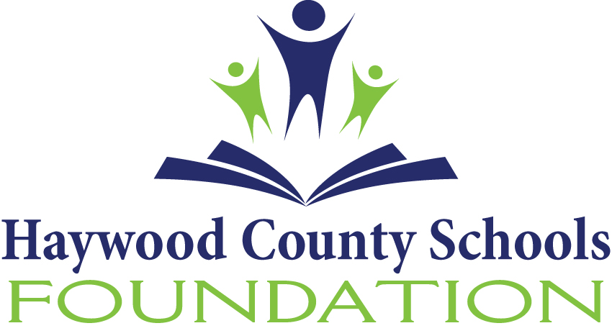
HAYWOOD COUNTY SCHOOLS FOUNDATION, INC.
1230 N. Main Street
Waynesville, North Carolina 28786
828.456.2400 Fax 828.456.2438
Federal Employer ID Number 56-1529355

June 10, 2020

Dear:

The Finance Committee of the Haywood County Schools Foundation is requesting proposals from investment advisory firms to provide investment advisory services. Proposals will be accepted from firms with demonstrated experience and competency in advising nonprofit organizations.

Minimum Criteria:

- The firm must have total assets under advisement of at least $4 billion.
- The advisory firm must have been in business for at least 15 years or must have a 10 year record of investment performance.
- The firm should demonstrate expertise and experience in serving the needs of nonprofit corporations, have expertise in foundation fund management, and be willing to provide a list of client referrals.
If your firm meets the criteria and is interested in responding to the request, please complete the enclosed Request for Financial Service and return it, along with five copies, to the address below by August 1, 2020.

Jenny Wood
Executive Director
Haywood County Schools Foundation
1230 N Main Street
Waynesville, NC 28786

Additional background information is attached. The finance committee of the Foundation will review the proposals and select several to make presentations to the committee prior to its recommendation to the Board of Directors. You will be notified via email upon receipt of your proposal.

If you have any questions or need additional information, please let me know. Thank you in advance for your attention to this matter.

Sincerely,

Jenny Wood
Executive Director, HCS Foundation
jwood@hcsnc.org
Enclosures

