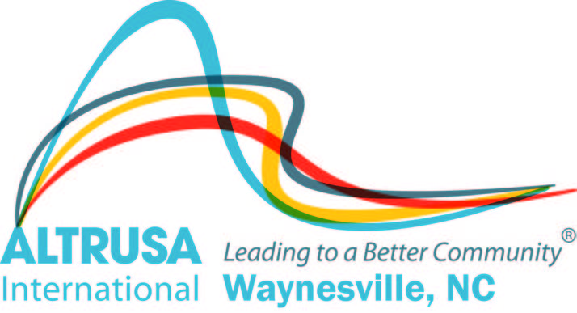

Altrusa International, Inc. of Waynesville Scholarships
Fact Sheet
Haywood County Schools Foundation, Inc.

The Altrusa Club of Waynesville is a volunteer service organization of business and professional leaders, dedicated to improving their communities through service. Scholarships have been established with the Haywood County Schools Foundation, Inc., to provide financial support to graduating seniors in the Haywood County Public Schools. The Haywood County Schools Foundation, Inc will administer the Altrusa International of Waynesville Scholarships. Amounts awarded to recipients range from $500 to $2,000.

ELIGIBILITY CRITERIA

- Haywood County Resident
- Graduating High School Senior from public school in Haywood County (Tuscola, Pisgah, Central Haywood, or Early College)
- Enrolled or accepted for enrollment in a North Carolina school as a full-time student in a two or four year curriculum.
  - Exception: ETSU is the only allowed out of state school
- *Financial Need (EFC from FAFSA REQUIRED)
- *Employment history (required)
- *Scholastic Achievement
- *Volunteer activities
- *Extracurricular activities
- *Essay – REQUIRED – On the standard application, where it says “In the space below please type a brief statement expressing your future goals, your interests, hobbies, etc., and why you want or need this scholarship,” the Altrusa Scholarship Committee reviews this essay for your goals, and why you need this scholarship.
- Past recipients may reapply directly through the Altrusa Scholarship Committee. Renewal is not guaranteed.

ELECTION PROCESS AND AWARD

A selection committee of the Altrusa Club of Waynesville will make a recommendation for the recipient of the scholarships. The selection process shall consist of a review and evaluation of the scholarship applications. The Board of Directors of the Foundation will make the final decision on the recipient of this scholarship. The Board’s decision shall be final. The Haywood County Schools Foundation, Inc., a tax-exempt charitable foundation, will administer the scholarship fund.

Non-Traditional students and Renewal applicants should contact the Altrusa Scholarship Committee directly. www.waynesvillealtrusa.org

