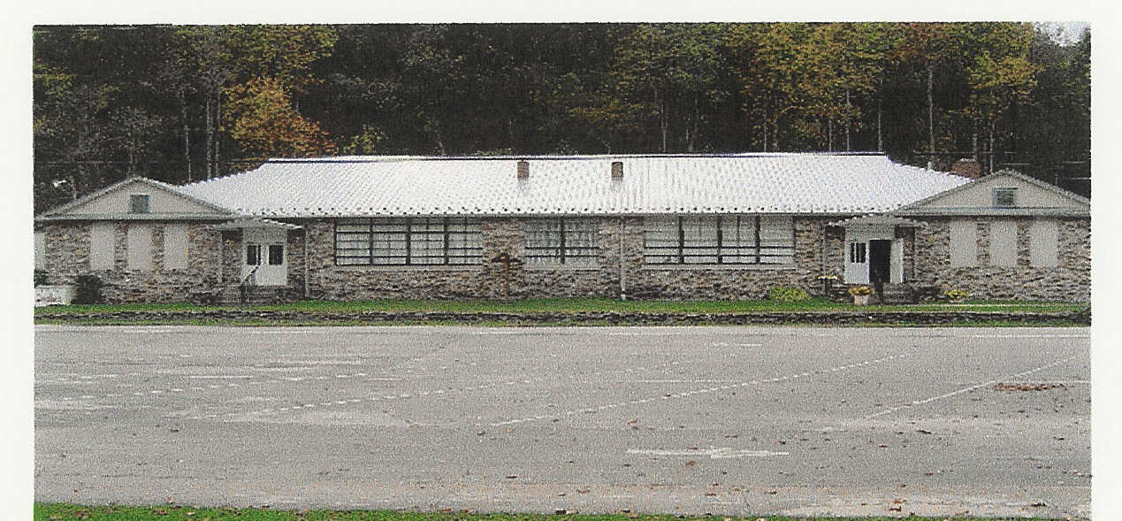

Cruso Friendship Club Jervis/Alexander Scholarship
Fact Sheet
Haywood County Schools Foundation, Inc.

The Jervis/Alexander Scholarships were established in 1998 by Dick and Pitsy Alexander. Essie Jervis and Pitsy Alexander were retired Teachers from the Cruso Community. It was their desire to help and boy and a girl, in need, from the Cruso/Bethel area graduating from Pisgah High School and going on to a college. The initial funds for the two scholarships were provided and are now, each year, raised through donations and fund raising events at the Cruso Community Center organized by the Cruso Friendship Club.

ELIGIBILITY CRITERIA:

- Grade point average 2.5
- Financial Need
- Graduating High School Senior from Pisgah High
- Acceptance at a school for higher learning
- Participation in extra curricular activities and Community service
- Demonstration of Leadership Potential

PROCESS:

A committee, appointed by the Cruso Friendship Club and the Foundation will make a recommendation for the recipient of the scholarship. The selection process shall consist of a review and evaluation of the scholarship application and possibly a personal interview. The Board of Directors of the Foundation will make the final decision on the recipient of this scholarship. The Board’s decision shall be final. The Haywood County Schools Foundation, Inc., a tax-exempt charitable foundation, will administer the scholarship fund.

PAYMENT OF AWARDS:

Payment of scholarship awards will be made by the beginning of the school year or at the beginning of each semester. The student cannot receive FULL scholarship from any other source in order to receive the scholarship. The Haywood County Schools Foundation reserves the right to revoke the scholarship if the guidelines are not met.

APPLICATION CHECKLIST

This application becomes complete and valid only when you have returned the SIGNED FACT SHEET, APPLICATION AND ALL SUPPORTING DOCUMENTS to your high school guidance department by Monday, March 25, 2011.

_______________________________SIGNATURE/APPLICANT_____________DATE

_______________________________PRINT NAME_____________________SCHOOL
By signing this sheet you have read the fact sheet and meet the eligibility require

