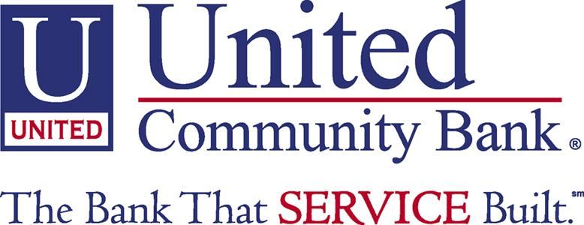

Fact Sheet
Haywood County Schools Foundation, Inc.
United Community Bank Scholarships

United Community Bank (formally Carolina Community Bank) has established two scholarships to be awarded this year. United Community Bank is a local community bank committed to education in Haywood County and Western North Carolina. Two $500 one-time scholarships will be available to any senior in the Haywood County Public Schools.

ELIGIBILITY CRITERIA

? Graduating Senior from Haywood County Schools
? Interest towards the business field
? Community involvement and extra-curricular activities
? Academic achievement
? Financial need

PROCESS

The Haywood County Schools Foundation will appoint a committee to review the applications. The committee will be composed of a teacher, guidance counselor, and board members of the Foundation. The committee decision will be final.

PAYMENT OF AWARDS

Payment of scholarship awards will be made at the beginning of the school year or at the beginning of each semester. Checks will be made payable to the school for student's account and will be forwarded to the financial aid office. A copy of the previous semester grades is required to be submitted to the Foundation before further payment will occur.

APPLICATION CHECKLIST

This application becomes complete and valid only when you have returned the SIGNED FACT SHEET, APPLICATION AND ALL SUPPORTING DOCUMENTS to your high school guidance department by Monday March 10, 2008.

________________________________SIGNATURE/APPLICANT____________DATE

___________________________________PRINT NAME_________________SCHOOL
By signing this sheet you have read the fact sheet and meet the eligibility requirements.

