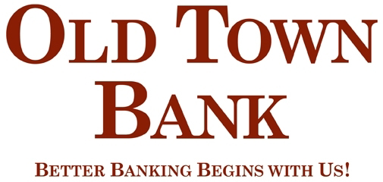

Fact Sheet
Old Town Bank Scholarship
Haywood County Schools Foundation, Inc.

Old Town Bank has established a scholarship to be awarded each year. Old Town Bank is committed to education in the Haywood County Public Schools. For the last few years they have been the lead sponsor for the Mari Gras Ball. Up to a $1,000 scholarship will be available to any senior in the Haywood County Public Schools.

ELIGIBILITY CRITERIA

- Graduating Senior from Haywood County Schools
- Preference given to students seeking a degree in Banking, Accounting, or
- Public Relations
- Community involvement and extra-curricular activities
- Academic achievement
- Financial need

PROCESS
The Haywood County Schools Foundation will appoint a committee to review the applications. The committee will be composed of board members of the Foundation and representatives from Old Town Bank. The Board of Directors of the Foundation will make the final decision on the recipient of this scholarship. The Board’s decision shall be final. The Haywood County Schools Foundation, Inc., a tax-exempt charitable foundation, will administer the scholarship fund.

PAYMENT OF AWARDS
Payment of scholarship awards will be made at the beginning of the school year or at the beginning of each semester. Checks will be made payable to the school for student's account and will be forwarded to the financial aid office. A copy of the previous semester grades is required to be submitted to the Foundation before further payment will occur.

