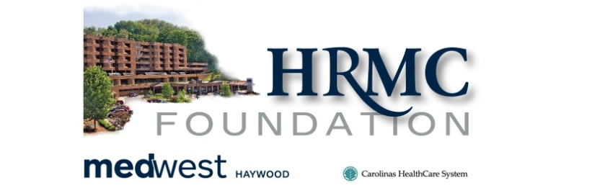

Fact Sheet
Haywood County Schools Foundation, Inc.

The Haywood Regional Medical Center Foundation (HRMC) has established a scholarship fund to be administered by the Haywood County Schools Foundation. The scholarships will be awarded to high school seniors from the Haywood County Public Schools. The scholarships will be awarded to students who are seeking a degree in the nursing profession. This year $2,000 will be available.

ELIGIBILITY CRITERIA

- Graduating High School Senior
- Seeking a degree in nursing
- Participation in extracurricular activities and involvement in community service
- Scholastic Achievement
- Financial Need

ELECTION PROCESS AND AWARD

A selection committee of HRMC Foundation will make a recommendation for the recipient of the scholarship. The Board of Directors of the Haywood County Schools Foundation will make the final decision on the recipient of this scholarship. The Board’s decision shall be final. The Haywood County Schools Foundation, Inc., a tax-exempt charitable foundation, will administer the scholarship fund.

PAYMENT OF AWARDS

Payment of scholarship awards will be made at the beginning of the school year or at the beginning of each semester. Checks will be made payable to the school for student's account and will be forwarded to the financial aid office. A copy of the previous semester grades is required to be submitted to the Haywood County Schools Foundation before further payment will occur. Cannot receive FULL scholarship from any other source in order to receive the scholarship.

