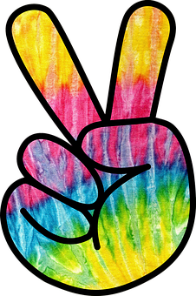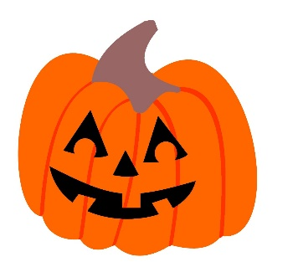HCLC is having “HIPPIE DAY” on HALLOWEEN

Thursday, October 31st

Dress in groovy 60s-70s gear (tie dye, bellbottoms, peace signs, etc.) to celebrate with us!

If you need help with accessories, please see Ms. Lisa!

Standard school dress code applies:

* No masks
* No blood/gore
* No clothing or costume props representing weapons, alcohol, tobacco, drugs, or paraphernalia
* No clothing that is “provocative or obscene” (School Board policy)
* Please avoid overly tight or revealing clothing (undergarments must be covered, no exposed midriffs, shorts must reach fingertip length)