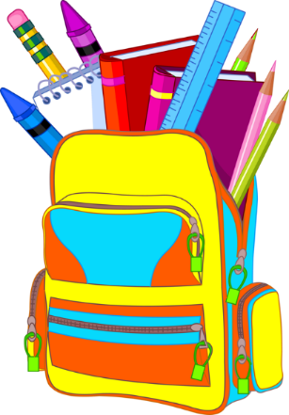 Supply Lists for

2019-2020 School Year…