Let’s Give ‘Em Something to Talk About
Mrs. Denton’s Speech/Language Newsletter Winter, 2016
Practicing Language Skills in the Car
by Erica Zollman, M.Ed., CCC-SLP
The car is a great place to practice speech/language
skills and strategies. Take advantage of time spent in the
car by playing some fun, language-based games.
Here are a few ideas:
• Categories: To play this game, one player chooses a category, such as “animals.” Every player takes a turn naming an item in the category. If a player repeats a word or is unable to name a word in the category, he/she is out. Play continues until one player remains and wins the game. To make this task more complex, have the child add more descriptive words to the category (i.e., animals with tails, animals that live in the zoo) or name animals alphabetically (eg., aardvark, bear, cat, dog, etc.).

• Rhyme Time: To practice phonological awareness skills, children can practice creating rhymes for things they see from the car window or in the environment around them. For example, if a child chooses the word “tree,” other players must name some rhyming words (e.g., knee, see, me). The player who gives the most rhymes is the winner! As an added bonus, players can create rhymes using nonsense words (e.g., slee, dree). Other players take turns identifying whether the rhyming word is a real word or a nonsense word.
• Cities and Syllables: As you pass through different towns, cities, or states, children can practice counting the number of syllables in that city or state’s name. For example, when passing through Idaho, the child counts or claps out three syllables. When passing through Tallahassee, the child counts/claps out four syllables. In a variation of this game, a parent chooses a particular number of syllables. Players look for words in the environment (e.g., road signs, billboards) that contain the specified number of syllables. Each player earns a point for finding a word. The player with the most points wins!
• Guess It: Players take turns describing familiar items or objects (e.g., car, apple, dog). The first player chooses an object and gives 3 clues to describe it. All of the other players take turns guessing what the first player is describing (e.g., it is a fruit; it can be red or green; it grows on a tree). If no players guess correctly, the first player gives another clue about the object. The player who correctly identifies the mystery object gets a point and chooses the next word to describe.

*Showtime: Choose age-appropriate DVDs to show children
in the car. As the movie plays, pause the film to ask
questions, such as:
- Who is that character?
- What do you think is going to happen next?
- Where does this story take place?
- When does this story take place?
- How does this character feel? Why? How can you
tell? When was a time that you felt that way?
- Who is your favorite character? Why?
- What was your favorite part of the movie? Why?

At the end of the film, have the child retell the story to another person in the car. The story should include characters, settings, chronological events, and a conclusion. Encourage the child to produce a story with a beginning, middle, and end. 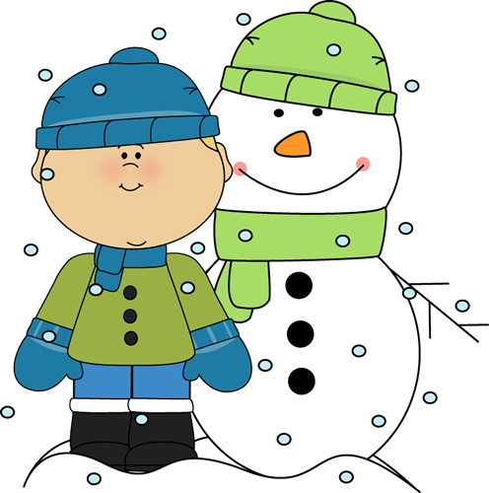
http://www.mycutegraphics.com/graphics/winter/boy-and-snowman-in-snow.html

10 ways to ask your child “How was school today?” without asking “How was school today?”
- Tell me about the best part of your day.
- What was the hardest thing you had to do today?
- Did any of your classmates do anything funny?
- Tell me about what you read in class.
- Who did you play with today? What did you play?
- Do you think math (or any subject) is too easy or too hard?
- What's the biggest difference between this year and last year?
- What rules are different at school than our rules at home? Do you think they're fair?
- Who did you sit with at lunch?
- Can you show me something you learned (or did) today?



If you ever have any questions or concerns about your child’s IEP or speech/language services, please call or email me! You can reach me at Bethel Elementary at 646-3448, ext. 3044

My email is gdenton@haywood.k12.nc.us

