5th Grade Supply List

wide rule paper

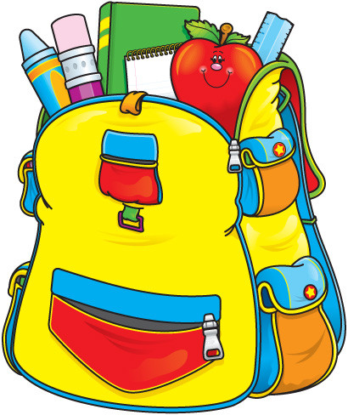
pencils (no mechanical)

pens (blue/black/red)

colored pencils

2 composition books (spiral)

3 ring binder (2 inches)

glue sticks

2 sturdy 2 pocket folders (with holes)

pencil pouch

scissors

4GB flash drive (optional)

book bag (no rollers)

