**Bethel Elementary**

**First Grade Supply List for 2015-2016**

* Large Pink Erasers (3pk)
* Glue Sticks (6 pk)
* TICONDEROGA Pencils (24 pk)
* Book Bag (no wheels)
* Plastic Pocket Folder w/ Middle Clasp (2)
* White 3-Ring 1” Binder w/ Clear Front
* Box of 24 Crayons
* Clip Board
* Box of Colored Pencils
* Pack of 1x1 Post-It Notes
* 1 highlighter
* 1 pack of thin dry erase markers
* Marble Composition Book (3)- Primary Ruled

(see picture below)

[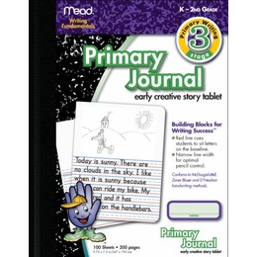](http://www.google.com/url?sa=i&rct=j&q=primary+ruled+composition+book&source=images&cd=&cad=rja&docid=_FTRKzOLSrlVTM&tbnid=pIyEICbMIY0m7M:&ved=0CAUQjRw&url=http://www.shopping.com/Mead-Compostion-BookSpecial-Ruled9-3-4-x7-1-2-WE-Paper-Bk-Cvr/mead-special-rule-composition-book/807398/reviews&ei=BJz0Ubv0Aoe09gTai4HgCw&bvm=bv.49784469,d.eWU&psig=AFQjCNExcktVD5qh-mL0AdA8WTlF1pq4qQ&ust=1375071552329435)