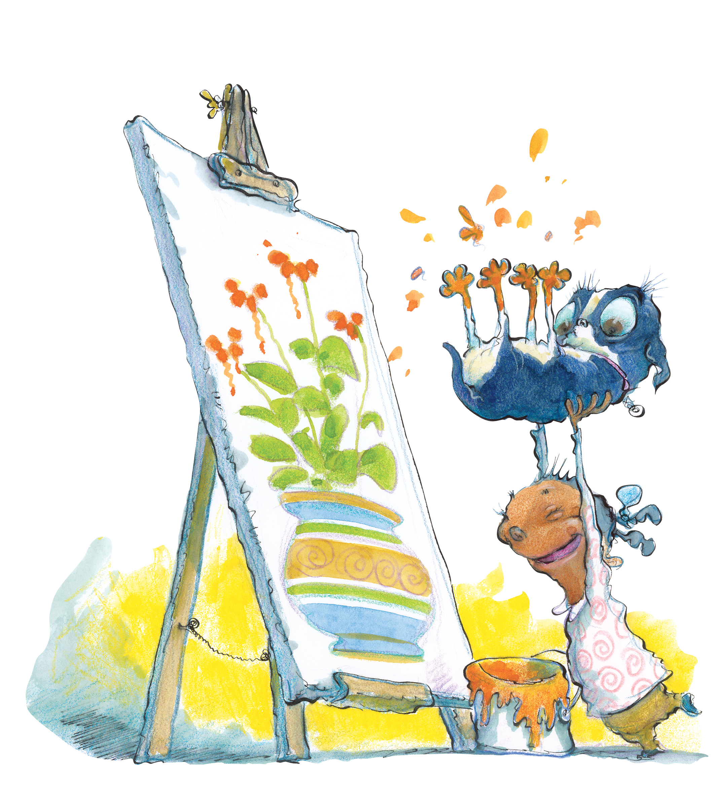
2009 Summer Reading Program
Be Creative @ Your Library!

SRP Kick-off Party
Saturday, June 6
10:00 a.m. – 2:00 p.m.
With Mountain Circus Arts performers
Juggling, clowning and FIRE EATING!

Teen Writing Workshops
Thursday, June 11, 18, 25, July 2, 9, 16
2:00 p.m. Waynesville
A series of writing workshops with area authors. Registration is required; workshops are free.

Mountain Music with Jeff Robbins
Thursday, June 11
11:00 a.m. Waynesville
2:00 p.m. Canton
Celebrate the beginning of your summer vacation with a free concert!

Doris Mager presents Birds of Prey!
Please note special times!
Tuesday, June 16 @ 10:30 a.m. Canton
Tuesday, June 23, @ 10:30 a.m. Fines Creek
Thursday, June 25 @ 10:30 a.m. Waynesville
Thursday, July 16 @ 1:00 p.m. Waynesville
Friday July 17 @ 10:30 a.m. Canton

Radio Controlled Helicopter Demo!
Tuesday, June 16 11:00 a.m. Fines Creek
Jim Lafer will bring his collection of radio controlled fliers to the Fines Creek library for a demonstration and a talk about the joys of collecting radio controlled vehicles.

Yo Yo Workshops
Wednesdays, June 17, 24 & July 8
Join local yo yo expert Connor Vranizan for a series of interactive yo yo workshops that will have you throwing like a pro!

Stories with Claire Ramsey
Thursday, June 18
11:00 a.m. Waynesville: Curtain Up!
2:00 p.m. Canton: Storytelling!
Come for a morning lesson in improvisation or for an afternoon of storytelling with versatile artist Claire Ramsey.

Secret Agent 23 Skidoo
Wednesday, June 24
11:00 a.m. Waynesville
2:00 p.m. Canton
Come sing along and dance along to hip-hop artist Secret Agent 23 Skidoo and Friends!

Don’t Miss Out!
Tuesday, June 30, July 7 and July 14
2:00 p.m. Waynesville
A series of fun, interactive workshops
on healthy habits for kids ages 8-12. Please call 452-5169 to register.

The Society for Creative Anachronism
Saturday, July 11
1:00 – 3:00 p.m. Waynesville
Step back in time with this presentation of medieval crafts, games and sword fighting by members of the Barony of Hawkwood.

Dusk Weaver
Wednesday, July 15
11:00 a.m. Waynesville and 2:00 p.m. Canton
Music for the whole family and our Summer Reading Program Finale!

Public Library Day @ the Ballpark with the Asheville Tourists!
Sunday, August 16
1:30 p.m. McCormick Field, Asheville
Join us at the ballpark for a day of fun and baseball. Enjoy the 150 foot banana split!

Seating is limited to 100 persons. Group reservations are available for 10 or more.

For more information contact:
Haywood County Public Library
Waynesville 452-5169 cdennis@haywoodnc.net
Canton 648-2924 lhartzell@haywoodnc.net
Or visit the library online:
www.haywoodlibrary.org or find us on Facebook!

