Haywood County Schools
1230 North Main Street
Waynesville, North Carolina 28786

828-456-2400

Anne Garrett, Superintendent

March 10, 2010

To: Parents or Guardians

The Haywood County School System believes that children mature at different rates and must be given the opportunity to learn at their developmental levels in an active child-centered classroom. We further believe that kindergarten focuses on the “whole” child in an environment that promotes self-worth, respect for others, natural curiosity, and self-expression.

We look forward to having your child become a part of our school system. Please complete and return the Information for Cumulative Record form AS SOON AS POSSIBLE. Return other forms by the first day of school.

If you have questions or concerns, please call your school.

Please Note:

PROVIDE COPY OF YOUR CHILD’S SOCIAL SECURITY CARD BY THE FIRST DAY OF SCHOOL

KINDERGARTEN HEALTH ASSESSMENT Every child entering kindergarten in the public schools must receive a health assessment. The Kindergarten Health Assessment must be completed for your child no earlier than 12 months prior to the date of school entry. A 30-day calendar grace period after school entry is allowed. (Example: For children entering school in August, 2010, the assessment must be done between August, 2009, and 30 calendar days after your child enters kindergarten). If the health assessment or immunizations are not completed by the end of the 30-day grace period, the principal is required to refuse your child’s continued attendance at school. You must use the health assessment transmittal form developed pursuant to GS 130A-441 (blue form).

SPECIAL HEALTH CARE NEEDS If your child has special health care needs such as asthma, food allergies or diabetes, teachers and school nurses should know about them and be able to help in emergencies. Your child’s health care provider will need to complete a Medication Authorization Form for all medications that your child needs to take while in school.
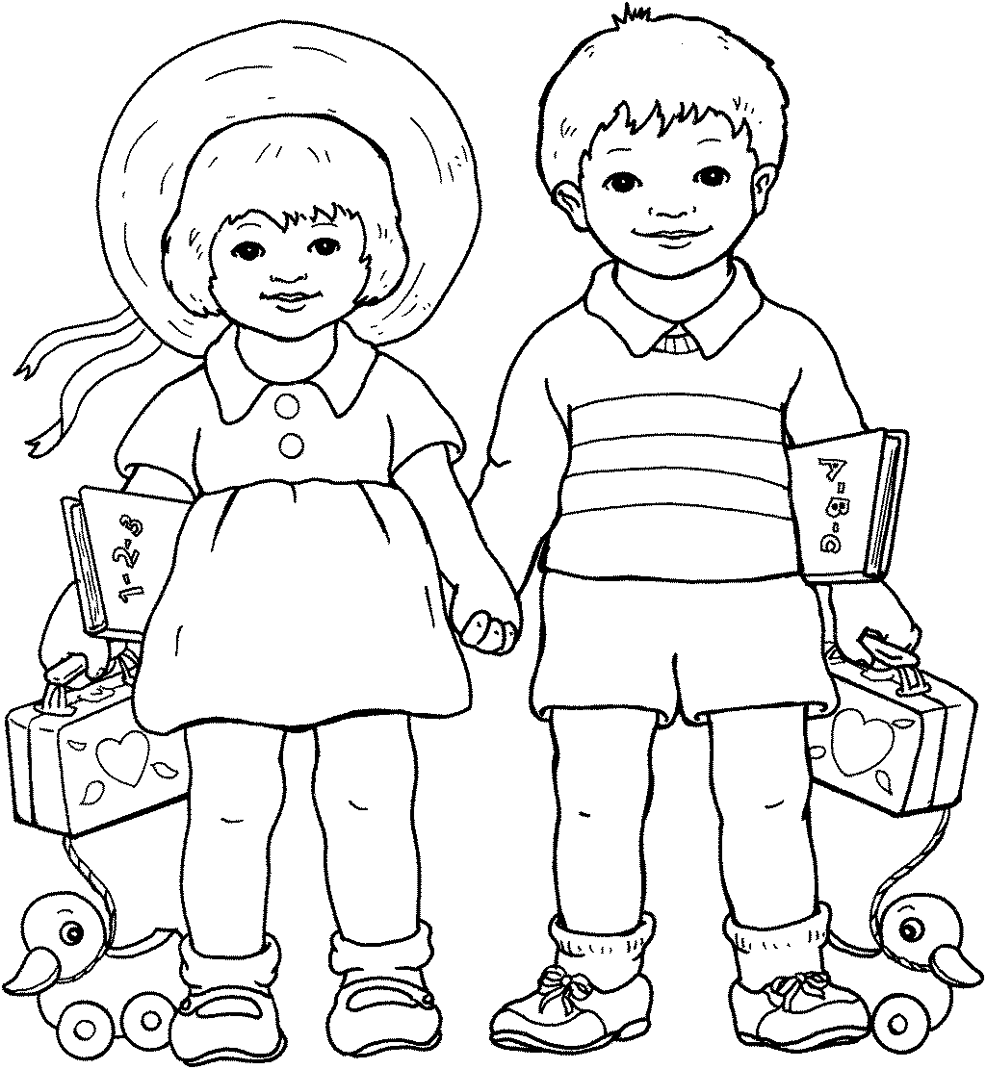

If your child has a chronic condition such as asthma or diabetes, you will want to develop an action plan or individual health plan of care with your child’s primary health care provider and the school nurse to make certain everyone knows what actions to take when your child is at school. If your child has special dietary requirements, your child’s health care provider will need to provide the school with a medical prescription for the special diet and dietary precautions. Please talk with your child’s teacher and other school staff about your child’s special health care needs and the school health care plan of care for your child.

STUDENT DATA

Birth Certificates for Kindergarten Pupils

North Carolina Law requires that kindergarten pupils be five (5) years old on or before August 31. Parents are required to furnish a certified copy of birth certificate or sworn affidavit to be filed in cumulative record of pupil. This must be submitted on the first day of school.

IMMUNIZATION DOCUMENTATION Attach copy of child’s immunization record on doctor’s office or health department’s form with the doctor’s name, address and signature showing on the form. No child shall attend a school (pre K-12) whether public, private or religious, unless a certificate of immunization indicating that the child has received the immunizations required by law is presented to the school.

What does the law now require for all children who enroll in Kindergarten or first grade?

- DTP, Dtap, or DT doses (If 4th dose is after 4th birthday, 5th dose is not required; DT
(requires medical exemption.)

- POLIO VACCINE doses (If 3rd dose is after 4th birthday, 4th dose is not required.)

1-4 Hib doses (Series complete if at least 1 dose given on/after 15 months and before 5.)

3 Hep B doses (children born on or after July 1, 1994 are required to have 3 doses.)

- Measles doses (at least 30 days apart; 1st dose on/after 12 months of age)

- Mumps dose (one dose on or after 12 months of age and before 16 months of age
The second dose before enrolling in school for the first time.)

- Rubella dose (on/after 12 months of age)

1 Varicella dose (Children born on or after April 1, 2001)

INFORMATION CONCERNING PUPIL
Student legal name: (Nickname):
Place of Birth: City: County: State:
Date of Birth: Age: Grade: Gender: Phone Number: Unlisted ____
Select One or More Race: American Indian or Alaska Native ___ Asian: ___ Black or African American: ___
Native Hawaiian or Other Pacific Islander: ___ White: ___
Ethnicity: Hispanic or Latino: ____ Not Hispanic or Latino ___
Present Mailing Address:
Community or Street:
Social Security Number: Medicaid I.D. Number:
Are there any Health Problems of which we should be aware?
Did your child attend pre-school program: Yes ____ No ____If Yes, number of Years_____
Place: City: State:

INFORMATION CONCERNING FATHER
Father or Stepfather’s Name: Place of Birth:
Mailing address if different from above:
Last grade Father/Stepfather attended in school: Occupation of Father/Stepfather:
Place of Work: Employer Address:
Employer Phone #: Cell Phone:
If Father/Stepfather is not living, give date of death:

INFORMATION CONCERNING MOTHER
Mother/Stepmother’s Name (include maiden name):
Place of Birth:
Mailing address if different from above:
Last grade Mother/Stepmother attended in school: Occupation of Mother/Stepmother:
Place of Work: Employer Address:
Employer Phone #: Cell Phone:
If Mother/Stepmother is not living, give date of death:

INFORMATION CONCERNING FAMILY
Does pupil live with someone other than parents? Yes _____ No _____
If yes, with whom: Relationship:
Total number of boys in family:
Total number of girls in family:
Full name and age of older children: Boys: Girls:

Full name and age of younger children: Boys: Girls:

EMERGENCY INFORMATION OTHER THAN PARENT OR GUARDIAN
Contact Person: Relationship:
Home Phone: Work Phone: Cell Phone:
Contact Person: Relationship:
Home Phone: Work Phone: Cell Phone:

GENERAL INFORMATION
Has student attended school in Haywood County before? If so, where?
Last school attended:
Address of last school attended:
Special check out instructions if any:
Transportation: Bus Number: Car Rider: Walker:
List people allowed to pick your child up (including inclement weather)(Use back if necessary):

Does your child have an I.E.P.?
Custody papers on file: Yes _____ No _____
Personal phone number you want Alert Now System to call:
Do we have permission to use your child’s name/photograph in the media? Yes ___ No ___

