Book Fair Information
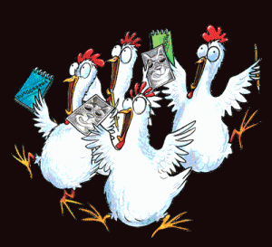

Dates: Friday, Mar. 27th - Tuesday, Apr. 7th

Family Read Day - Friday, Apr. 3rd - 7:45AM - 4:30PM

(A family member can come any time Friday, get their child/children out of class, come to the library to read together.)

Get a Homework Pass by coming during evening hours on

Thurs., Apr. 2nd or Tues., Apr. 7th

3:00PM-8:00PM

Thank you for supporting our school library!!!

