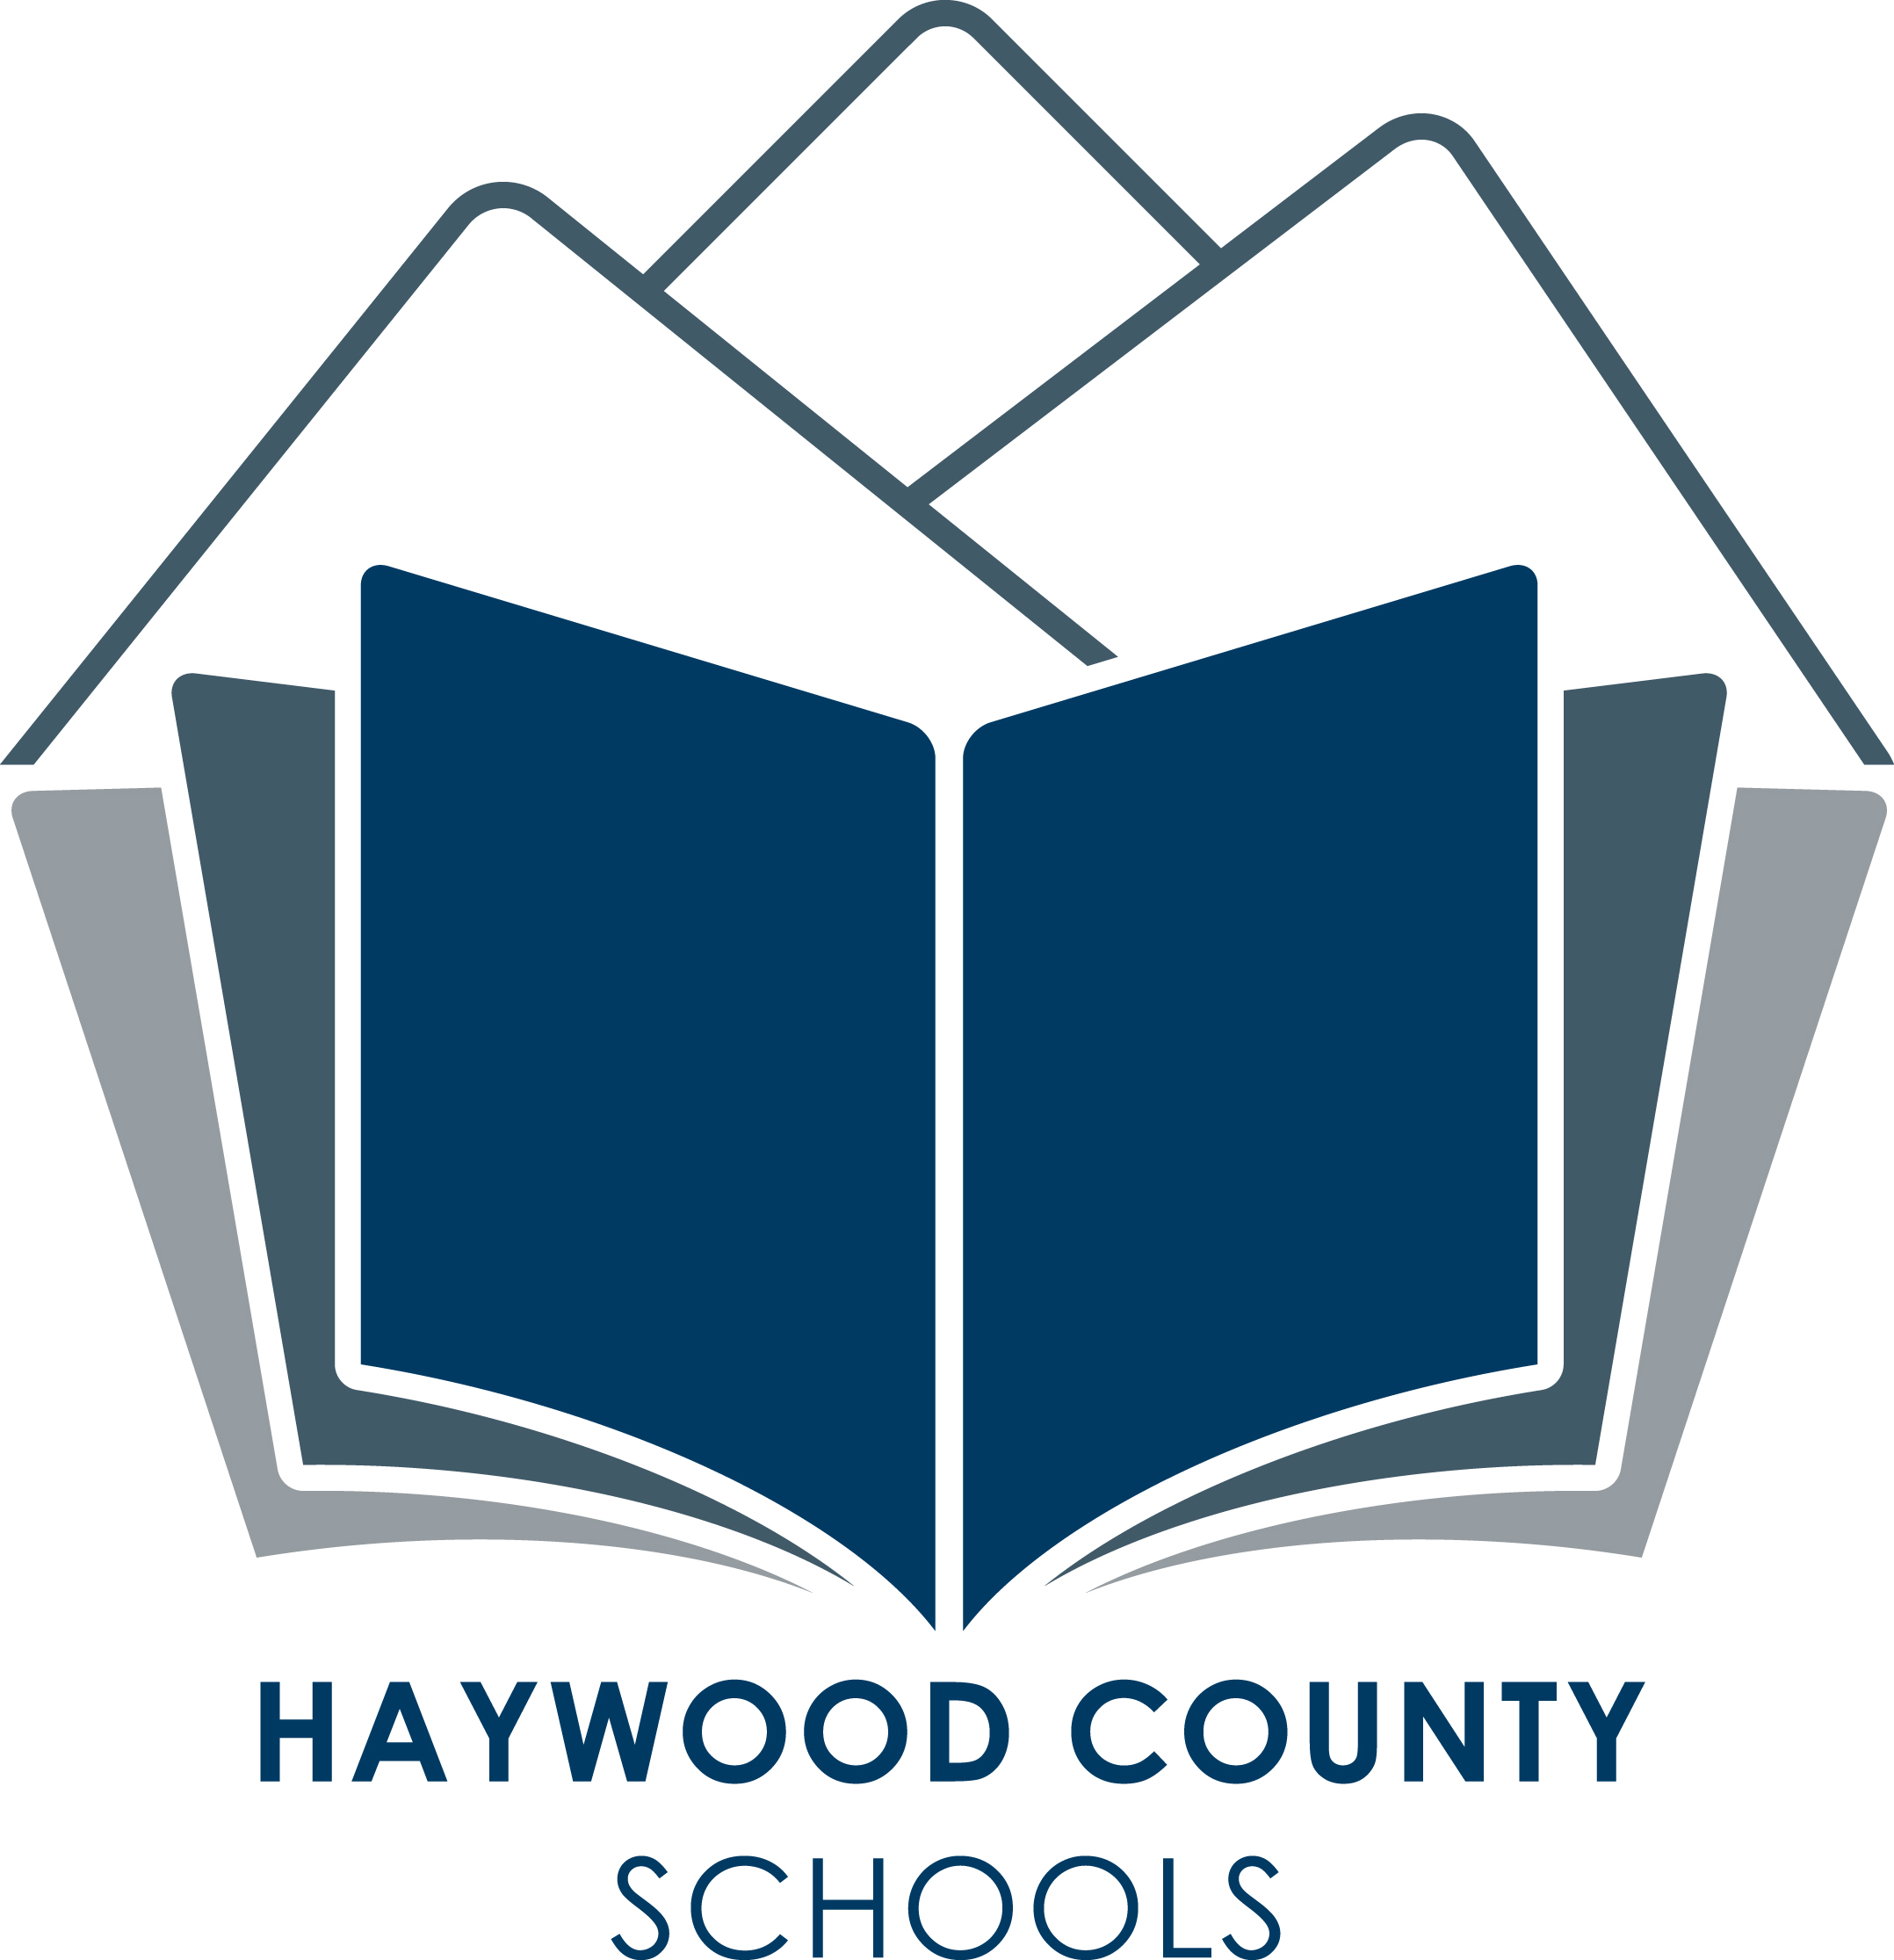
Haywood County Schools
1230 North Main Street
Waynesville, NC 28786
828 456 2400

Anne G. Garrett, Ed., D.

Superintendent

July 8, 2015

Dear Parent/Guardian:

Central Haywood High School is participating in a Universal Lunch and School Breakfast Program for the current school year 2015-2016. If your child(ren) attend Central Haywood High School, breakfast and lunch will be available to them at no charge. All students enrolled at this school may participate in the breakfast and lunch program at no charge to them.

Studies have shown that children who are not hungry perform better in school. By providing lunch to all children at no charge, we are hoping to create a better learning environment for our students.

The school breakfasts and lunches that we serve follow U.S. Department of Agriculture guidelines for healthy school meals. The School Breakfast and Lunch Programs cannot succeed without your support; please encourage your children to participate in the school meal programs.

Meals will be served to all students at no charge regardless of the eligibility status. No further action is required of you. Your child(ren) will be able to participate in these meal programs without having to pay a fee or submit an application.

Additional items are still available for purchase.

If you have any questions about the program please feel free to contact us at 828-627-1150.

Sincerely,

Alison C. Francis
Director of Child Nutrition



Board of Education
Charles H. Francis, Chairman; Lynn Milner, Vice-Chair;
Jim Harley Francis, Larry Henson, Steven Kirkpatrick,
Walt Leatherwood, Bobby Rogers, Jimmy Rogers, Rhonda Schandevel

