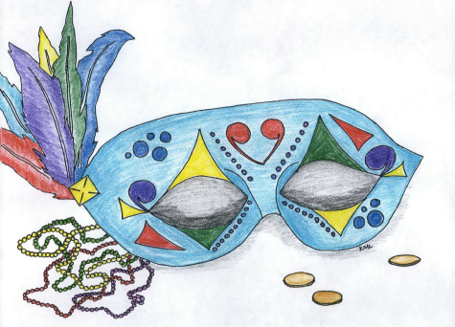

**Queen Candidates**  
Noralynn Grindstaff  
Niki Henry

**King Candidates**Jason Greene  
Dr. John Highsmith  
Travis Hyatt

**Ball**

**Mardi GRAS**

***Saturday, March 1st***