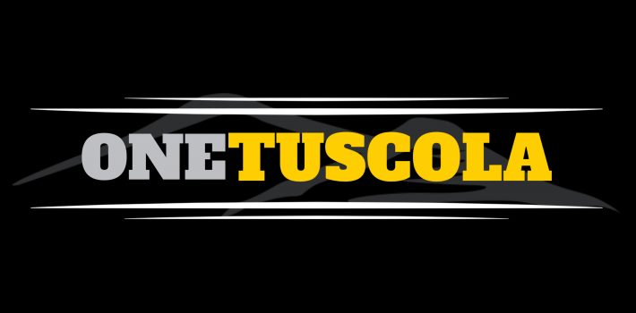
Counseling Center News
Week of June 1, 2020

LAST COUNSELING CENTER NEWS OF 2019-20!
We have surely enjoyed working with you this school year.
We hope you have a wonderful summer break!
Just a few reminders:

- SUMMER READING for Honors / AP English, AP US History / AP Government, and Honors Earth Environmental Science is located on the THS Website: http://ths.haywood.k12.nc.us/2020/05/21/summer-reading-2020/

- ATTENTION JUNIORS! Are you interested in learning more about the following 5 merit scholarships?
- Cheatham-White at North Carolina Central University
- EC Scholars at East Carolina University
- Levine Scholars at the University of North Carolina at Charlotte
- Morehead-Cain at the University of North Carolina at Chapel Hill
- Park Scholarships at NC State University
If you are interested in any of these scholarships, the application process for each will start in September.
PLEASE LEARN MORE about these 5 scholarships at
- https://www.youtube.com/watch?v=Q4w4LJSRq_M&feature=youtu.be (video)
- https://park.ncsu.edu/wp2018/wp-content/uploads/2020/05/NC-Merit-One-Pager.pdf (information sheet)
- There will also be opportunities to join live webinars: Sign up at https://docs.google.com/forms/d/e/1FAIpQLSc2jm7qT6vXBPlKxx-LSaRUWBxzBlmAOpN9yKg7l-xPw6abcQ/viewform.

- Juniors interested in taking the ACT (again) or the SAT are encouraged to follow updated test administration information on their respective websites!

- CONGRATULATIONS CLASS OF 2020: June 2 & June 3--After all students have had the opportunity to “cross the stage” a video of the entire event will be provided--including musical selections, speeches by students, and recognizing this year’s “Most Influential Teacher.” Please wear your cap and gown and appropriate attire (“business casual”—no shorts, t-shirts, or flip-flops). There will be an area reserved for photos, and seniors will be given a personalized graduate sign.

- HCC Tuition Free Guarantee: Now requires a 2.5 GPA! Learn more and apply at https://www.haywood.edu/financial-aid/scholarships/tuition-free-guarantee

CLICK HERE for full Scholarship Listing!

CLICK HERE for full Student Opportunity Listing!

Ms. Russell krussell@haywood.k12.nc.us Ms. Heinz theinz@haywood.k12.nc.us Ms. Plott jplott@haywood.k12.nc.us
Mr. Johnson aajohnson@haywood.edu Ms. Epps eepps@haywood.k12.nc.us Ms. Dove adove@haywood.k12.nc.us
Ms. Kennedy jkennedy@haywood.k12.nc.us Ms. Agostini meghan.agostini@meridianbhs.org Dr. Ensley rensley@haywood.k12.nc.us

