Dear THS Students, Staff, and Families: August 2019
Due to changes in Remind this past July, the THS Counseling Center will no longer have access to Remind groups large enough to communicate with ALL of our students. As a result, we will be transitioning to Google Classroom this year. After researching several options, we selected Google Classroom since many of our students and families already use this platform with other THS teachers; additionally many employers and colleges choose to communicate professionally with students via email. PLEASE join your THS Counseling Center classroom to get information about student opportunities, upcoming scholarships, course registration information, and MORE!
Class Codes:
Class of 2020: gz79wt Class of 2022: 6v1yl8
Class of 2021: obcg82e Class of 2023: 1pk3w5

How do I join a class?

Note: You have to have a Google email in order to join.

You will be asked for your Google username and password.
- Go to classroom.google.com.
- At the top, click Add Join class.
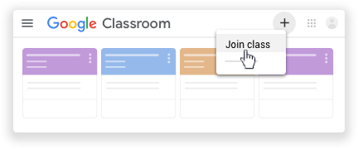
- Enter the class code your teacher gave you and click Join.
A class code consists of 6 or 7 letters or numbers. For example, hjhmgrk or g5gdp1. 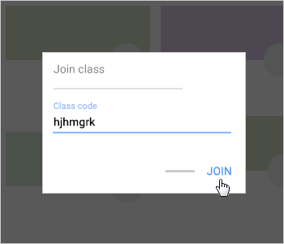

How do I Install Classroom to my mobile device?

Android
To use Classroom on your Android device, download the Classroom app from Google Play.
- On your device, tap Google Play Store.
- Find and install the Google Classroom app.

IPhone and iPad
To use Classroom on your iPhone® or iPad®, download the Classroom app from the App Store.
- On your device, tap App Store.
- Find and install the Google Classroom app.

Chrome OS
The Classroom app for Chrome OS works like a bookmark to the web version of Classroom. You can download it from the Chrome Web Store.

If you have any questions or ideas for communication, please let us know. We are excited to begin a new school year!

Ms. Dove, Registrar
adove@haywood.k12.nc.us

Ms. Russell, Counselor for students with last names A-G
krussell@haywood.k12.nc.us

Ms. Heinz, Counselor for students with last names H-O
theinz@haywood.k12.nc.us

Ms. Plott, Counselor for students with last names P-Z
jplott@haywood.k12.nc.us

Mr. Johnson, Career Coach

Ms. Kennedy, School Social Worker

