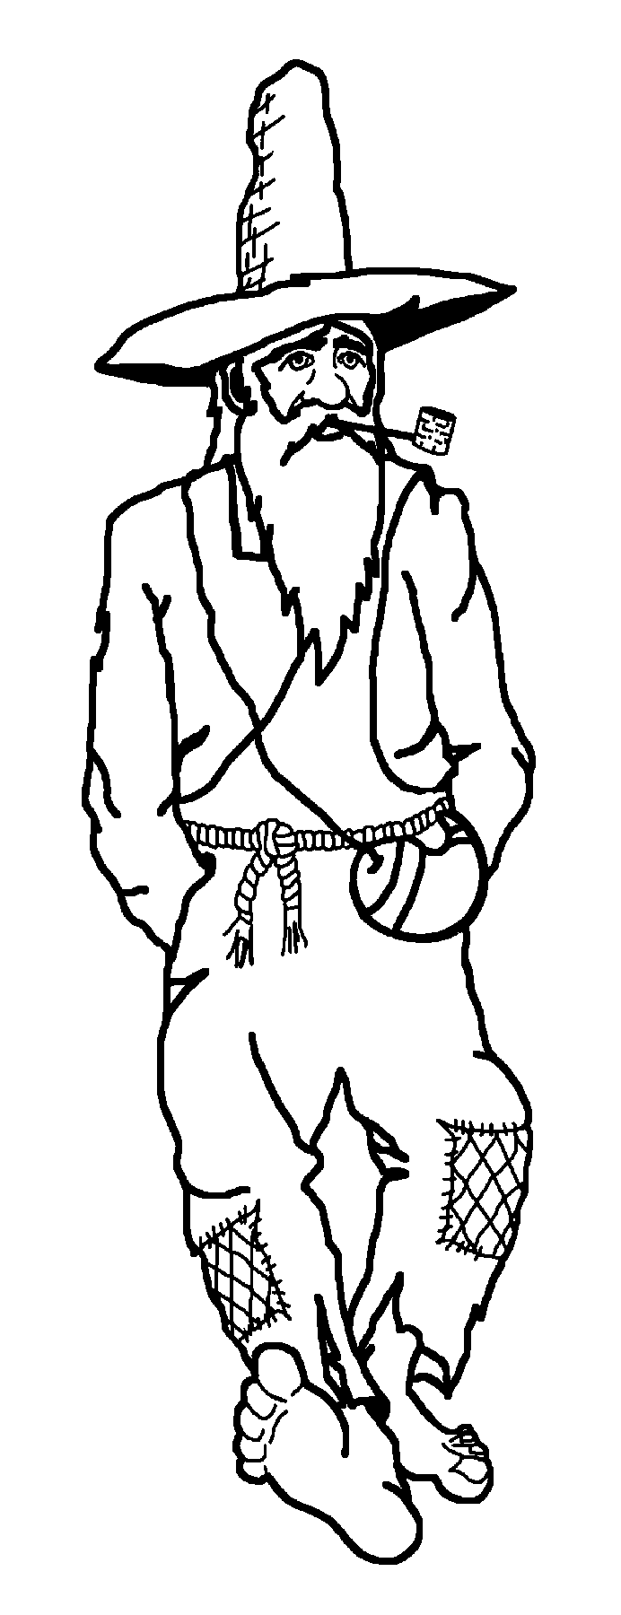
Tuscola High School
Publications Department
564 Tuscola School Rd.
Waynesville, NC 28786
Phone: 456-2408
Fax: 456-2434

Important Dates:
Reserve ad $40 - Sept 1
Pictures due - Oct 2
Make up senior pics - Sept 6
Final ad payment - June 1, 2018

Dear Parents/Guardians of seniors,

Attached you will find an order form to reserve senior “baby ad” space in the 2018 yearbook. The Mountaineer again will be published entirely in color. We will once again offer the popular combination package of a personalized yearbook AND full page ad for 10 monthly payments.

We will also offer payment plans for smaller ads (without yearbook). The prices and payment installment plan is outlined on the order form; however, other payment arrangements can be made if necessary.

The due date for reserving space with a deposit of $40 is September 1st (don’t panic; pictures are due later!). Because there is a limited amount of space available, we must strictly honor first come, first serve status. Also, we are offering to print a copy of the senior baby ad on photograph paper in full color as a keepsake for parents, grandparents, aunts and uncles etc. So much thought and care is put into the ads for the yearbook, we want families to be able to enjoy their own copy for a low cost.

Please return the order form and a minimum payment of $40 to the Publications office in B-2 or to the above address on or before September 1st. The deadline for pictures is Oct 2nd. This should allow time for senior pictures to arrive if you want to include those on your senior’s page (It is not necessary to purchase senior pictures to be in the yearbook. We do ask that seniors have one formal and one casual photograph made to be included in the yearbook, but no purchase is necessary). The make up date for senior pictures is Wednesday, Sept 6th.

Please feel free to call with any questions or drop by the school to view previous years’ ads. We will also have some senior ads on display during Open House September 5th in B-2. Feel free to stop by and check them out! The easiest way to reach me with questions is tbates@haywood.k12.nc.us.

Thanks so much for your support,

Tammy Bates

