Spring Sports 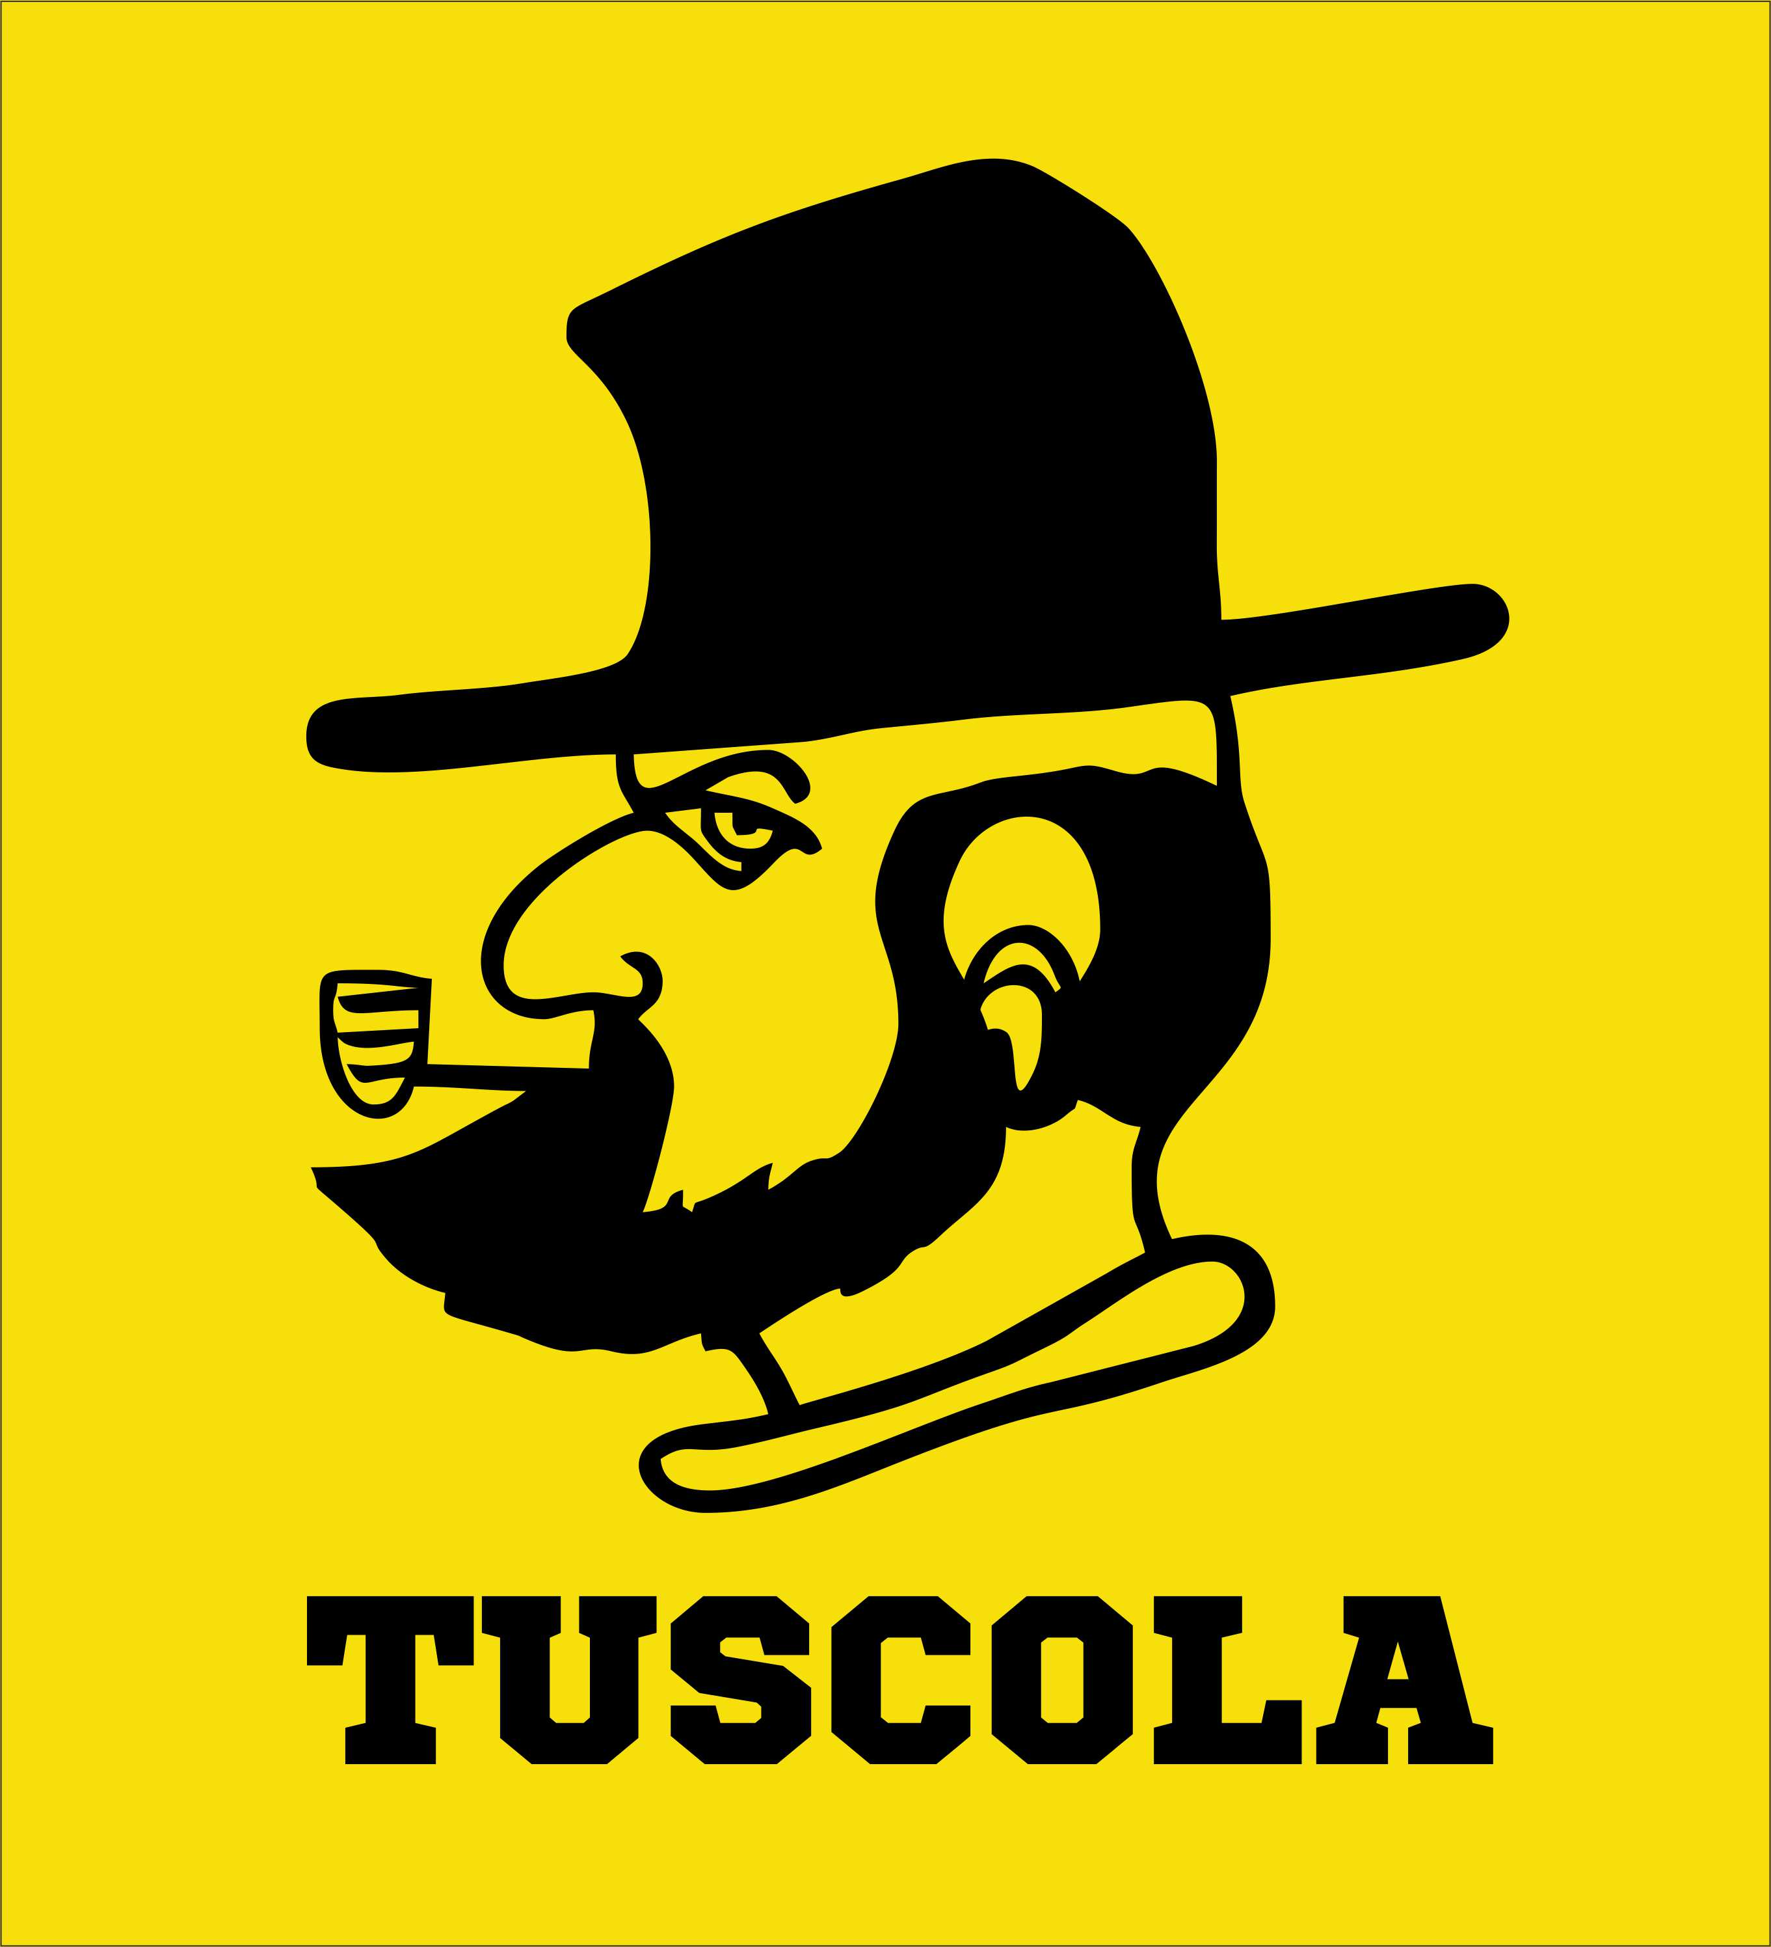Spirit Week

Week of March 21-24

Support our women’s soccer, softball and track teams and men’s golf, tennis, baseball and track teams by dressing up for each spirit day.

Mon March 21 Soccer vs Pisgah Home AMERICA DAY

Tues March 22 JV/Varsity Baseball vs Pisgah Home CAMO/BLACK &

JV/Varsity Softball vs Pisgah Home GOLD DAY

Wed March 23 Tennis vs East Away 70’S DAY

Track vs East Away

Thurs March 24 “SPRING” OUT THE PASTELS DAY

Fri March 25 NO SCHOOL

*Follow and send a pic to @TuscolaYearbook for a chance to win the special 50th edition yearbook arriving in May.*