2010-2011 The Mountaineer

Yearbook Application

The Mountaineer Publications Staff is looking for excited, dedicated, hard-working, and enthusiastic students to create the 2010-2011 yearbook. If YOU fit this description, complete this application and return it to Mrs. Bates in room B-2 no later than Wednesday, January 20, 2010.

Please complete all portions of this application. Incomplete applications will not be considered.

Name: _________________________________________________Current Grade: 10, 11

Address: _____________________________________________________________________

City: __________________ ZIP: ________________ Home Phone: __________________

E-Mail Address: ______________________________________________________________

Parent/Guardian Name(s): ____________________________ Birthday: _______________
________________________________________________________________________________________________________________________
Part 1:

- All staff members will be responsible for designing pages, writing text and captions, and editing written work. Publications students are also responsible for taking the pictures that will illustrate the yearbook. *All students may be required to attend extracurricular activities and take pictures, and so good grades and attendance are a must.

Current Class Schedule

1st Period Teacher: _______________________ Grade ____ 5th Period Teacher: ________________________ Grade ____

2nd Period Teacher: _______________________ Grade ____ 6th Period Teacher: ________________________ Grade ____

3rd Period Teacher: _______________________ Grade ____ 7th Period Teacher: ________________________ Grade ____

4th Period Teacher: _______________________ Grade ____

(You can record your 1st semester report card grade yourself or make a copy of your report card and attach. Please don’t ask the guidance counselors or teachers.)

Have you ever had to make up time to receive credit for a class?_______ Which semester(s)?______________________
If yes, how many classes per semester did you have to make up time for?
If yes, please attach an explanation of your attendance record.

Present and past Tuscola High School English teachers:

Teacher: _____________________________________ Year: _______________ Grade: A B C D F

Teacher: _____________________________________ Year: _______________ Grade: A B C D F

Teacher: _____________________________________ Year: _______________ Grade: A B C D F

Part 2:

2010-2011Yearbook Requirements (Minimum)
- Submit two mini-deadlines for each page or section assigned (15 mini-deadlines during the year).
- Learn InDesign CS 3 and Jostens Yeartech.
- Sell at least $400 of business advertising before August 15, 2010.
- Attend at least 3 events per page/section assignment (sports, arts, etc.).
- Complete year-end project.
- Help with yearbook distribution (end of school year).

- List any extracurricular activities you will be involved in, and the season or time of year you will be involved in them.

- Do you feel comfortable with computers? Yes No

- What computer programs are you most familiar with? (We mostly use Microsoft Excel and Word, Adobe Photoshop, Adobe Illustrator, Adobe InDesign CS 3)

Would you consider yourself to be proficient with these programs? Yes No

4. Do you have experience with computer networking? Yes No

- Do you have access to a car during the school day? (not necessary) Yes No

- Are you able to spend time after school working on the yearbook to help meet deadlines? Yes No

- Have you ever used a digital camera? Yes No

- Do you have a digital camera that you can use for this class? Yes No
(This in NOT a requirement)

- What do you think working on the yearbook entails?

- Please explain in detail why you want to be on the yearbook staff (add page(s) if necessary).

11. Explain why I should select you over everyone else applying for the open positions. Include unique abilities and strengths that you feel make you exceptional. (Remember, you are competing with other students for a limited number of positions—don’t be afraid to sell yourself and your abilities.)

Application is due Wednesday, January 20th.
Name: ______________________________________ Next Year’s Grade: ____________

Imagine that you are completing a page for the yearbook. This is the picture that has been chosen for your page. Write a fictitious caption that describes the event and includes a descriptive statement. Include names, dates, places, and what is happening. (The first sentence of a caption should be written in present tense, as if the action in the picture is happening right now. The following sentence(s) should be written in past tense, elaborating on the picture by giving the viewer more details)

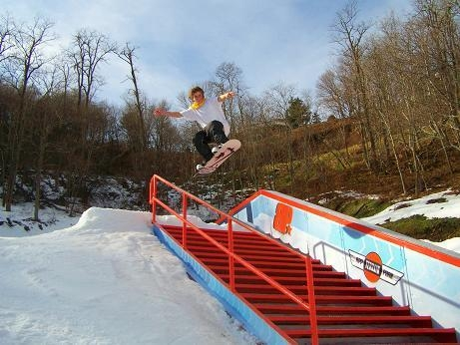

Imagine that you are now writing the copy (paragraph of text) for your page and this picture exemplifies the event that you are reporting on. Write a paragraph that describes the event (you don’t have to use actual details from the real event—make them up!).

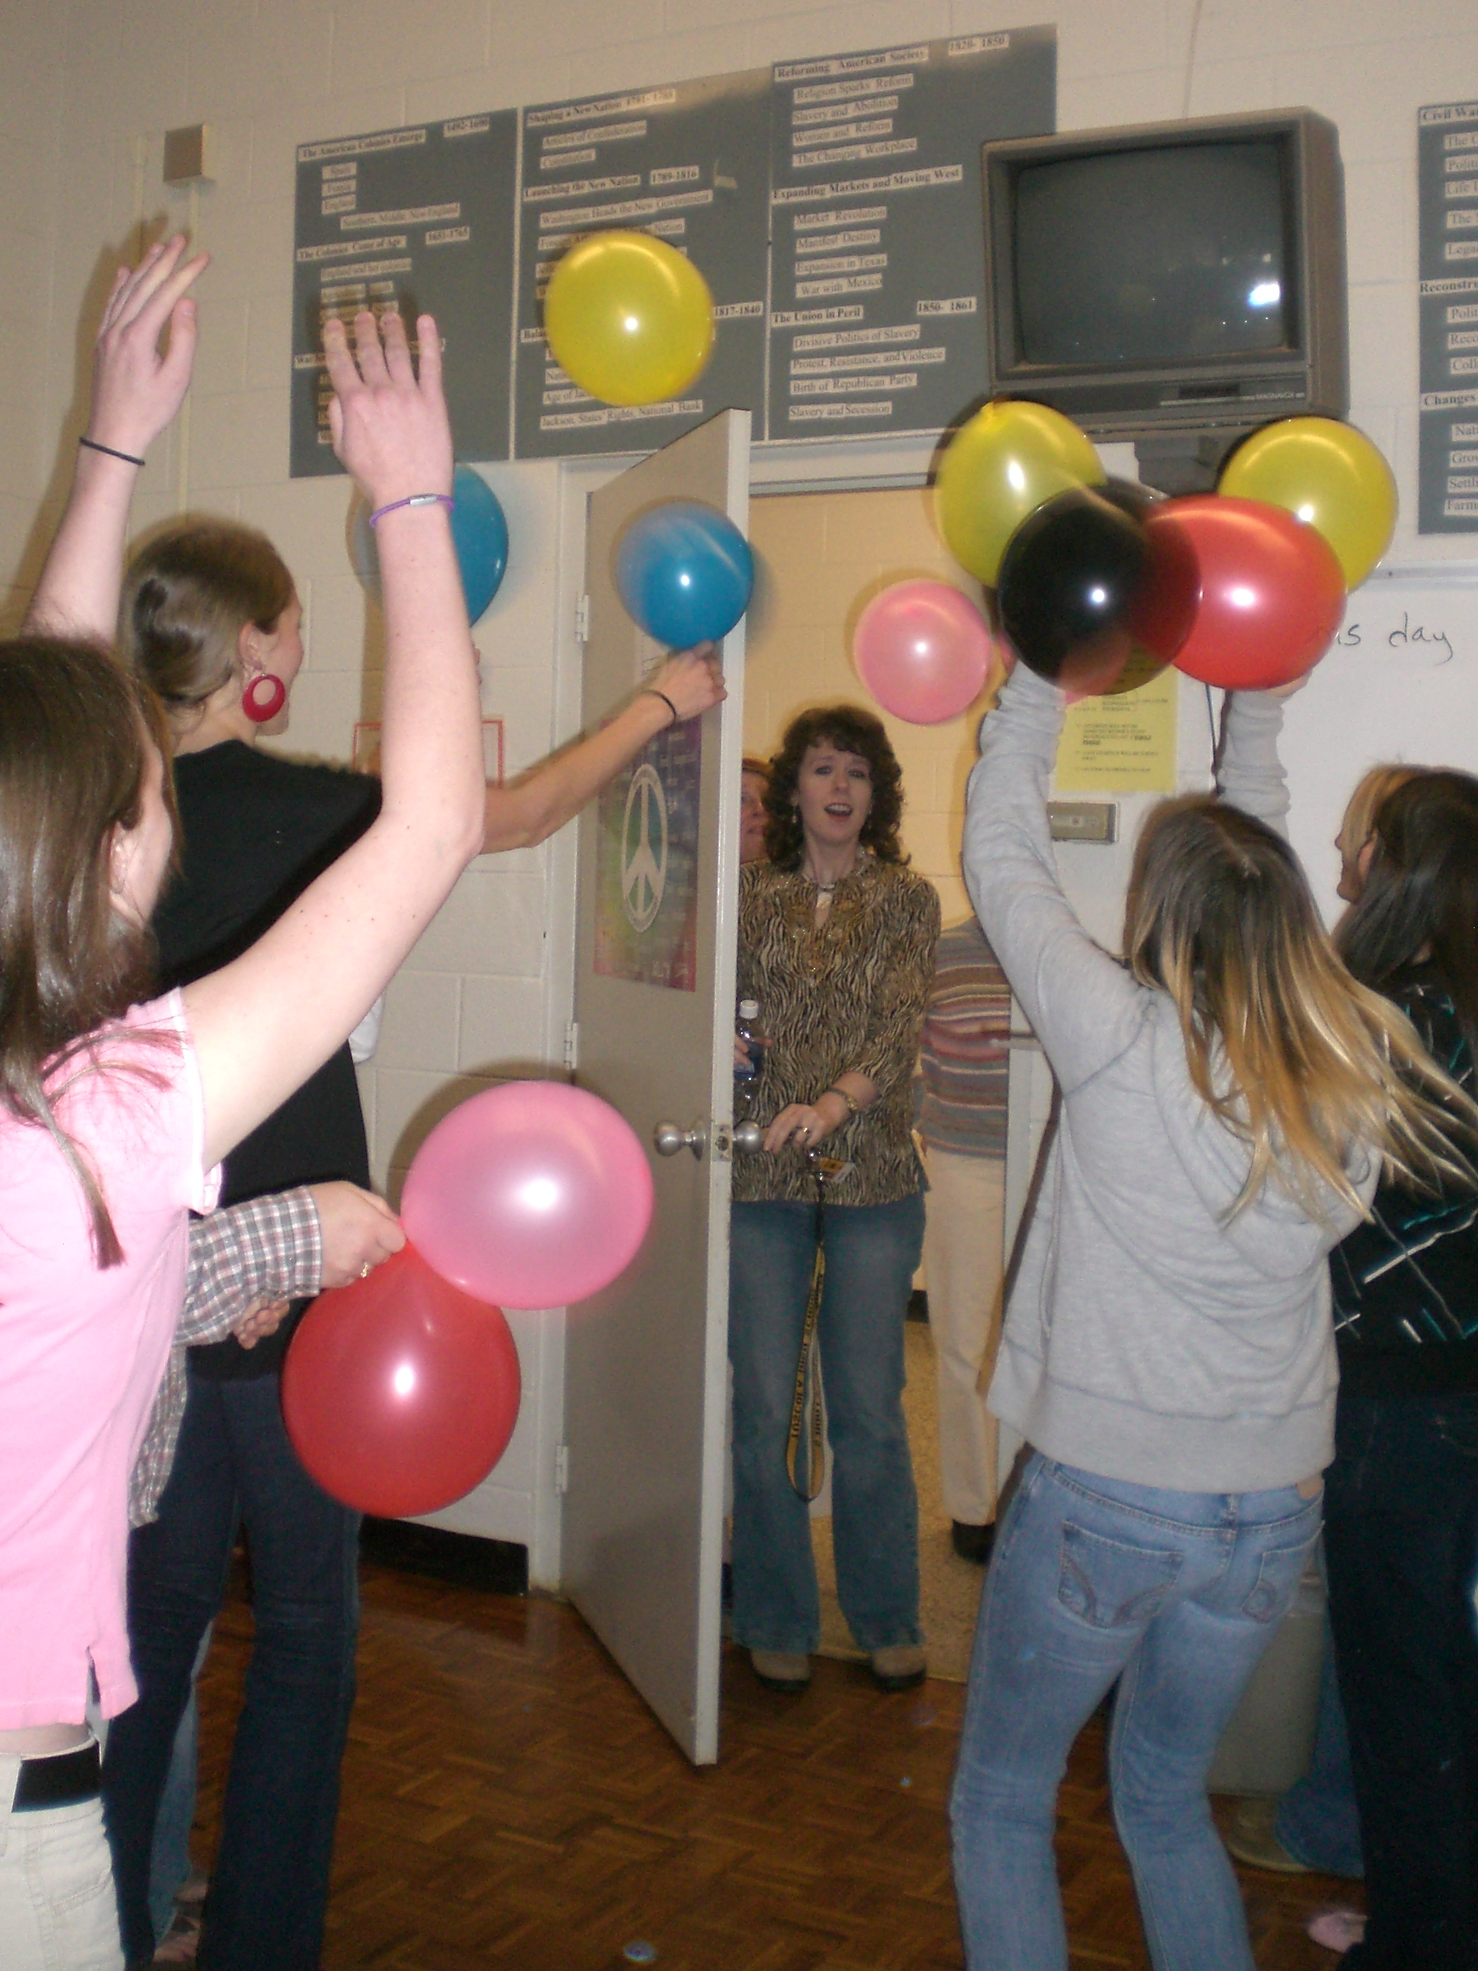 Application is due Wednesday, Jan. 20th.

