
Alumni e-Newsletter
Fall 2009
Volume 1 Issue 1

Message from Our Principal
Mountaineer Alumni,
We hope that you will take the time to visit and browse our new Tuscola High School website. With the additions and links associated with this site, I am sure that you will be pleased. We continue to encourage our students to be involved in as many aspects of the school day and high school experience as possible. Our unique scheduling offers students many opportunities throughout their high school years. Our excellence in state, SAT, and AP test scores and the increase in scholarship money that our students receive continue to exceed the state’s expectations. I thank you for being a part of our Tuscola family. We hope that you will contact us if you have questions or concerns.
Respectfully, Dale McDonald

To Our New Alumni
Class of 2009,
The time is drawing near for us to branch out of our close-knit community in Haywood County into a new niche of our choice. Although it is our time to exit a place where we have left our mark, we will prove just how determined we truly are as we make a difference in our new environment. I have faith that all of you will continue to make a difference through your strong morality no matter where your life leads. Throughout our school years together, I have witnessed you give support and help to the people of our community and school. Together we have accomplished many kind acts such as helping the elderly, assisting the financially needy, and becoming mentors for younger students, and these are only a few examples of our classmates’ efforts to serve our community. I could not have asked for a more caring, humble class to graduate with in 2009. We each have our own unique personalities, but I know for a fact that each one of us has molded one another into the persons we are today. As we will be graduating on June 10, I have been reflecting on the school events we have attended, the challenges we have all faced, and, most importantly, the relationships we have formed. Tuscola has given us a place to gain knowledge and develop different passions together while building the fundamental skills we will need in the future.
Without the faculty and administrators of Tuscola, we would not be the young adults we have become. Whether we realize it or not, they have instilled important values, such as integrity and compassion while ameliorating our gifts and talents. Our teachers have sparked a flame of a desire to learn, and it is up to us to ignite the fire and utilize our knowledge. The gifts we possess, whether it be the hands of a mechanic, the proficiency of a surgeon, or the knowledge of a teacher, have been enhanced through the nurturing of our faculty at Tuscola. We have an enriched education that has prepared us for the next level in our lives to achieve our goals. I extend my best wishes to each one of you in your future; I can not wait to celebrate all of the future accomplishments of our Class and the contributions they will give to improve our world. We will cross paths in the future, or may stay in close contact, but, however far we part, never forget where you came from and the strong values we have learned from our mountain heritage.
As the final curtain closes on the Class of 2009 and we exit the Tuscola High School stage to embrace new endeavors, I hope we will always continue to serve others through our gifts and talents as we may find that helping others is truly the greatest measure of success after all!
Best of luck,
Grace Williamson
SGA President 2008-2009

Message from the 2009-2010 Student Government Association President
I would like to introduce myself as the SGA President for the school year 2009-2010 and invite you all to our SGA meetings every 2nd and 4th Thursday after school in room D-2. Your attendance and input would be greatly appreciated. Our student government is very excited and striving to make a big impact this year, and any advice, ideas, or help would be absolutely wonderful to have. We want to create a strong bond between our school and community, and that can start with you. If you would like to contact me, my email address is soccerkat727@yahoo.com.
I hope to hear from you soon,
Kathryn Ray

FIGHT SONG
On Tuscola, on Tuscola
Fight right through that line
Draw a circle 'round ole Pisgah
As we did in days of old
So, on Tuscola, on Tuscola
Fight right through the night
We're for you Mountaineers
So win this game



*1st Alumni Event*
Join us Friday, October 16th, at the Tuscola/Pisgah football game. Sign-in at an alumni table, located at each entrance, and place an order for some alumni apparel. Then, beginning at 5:30 p.m., near the back gate, Doug and Wanda McCracken will be hosting a wild meat potluck. Bring a dish, make a donation, and tailgate a while. (Remember that parking is reserved behind the home side.) Kick-off is at 7:30 p.m.

If you have not been to C. E. Weatherby stadium in a couple of years, you will see a few changes. First of all, artificial turf was installed last year. Secondly, take a stroll along the Path of Pride (more information follows). Finally, we moved into a new conference this year – the Appalachian Athletic Conference. Currently, the football team has two wins, one loss, and one tie.
As always, if you cannot attend, you can listen to the game on 1400 AM or stream it online at http://www.am1400thepeak.com. For post-game information, go to http://tuscolafootball.com/ or follow Tuscola Football on Twitter.

The Path of Pride
The Path of Pride at C. E. Weatherby stadium is a fundraising project initiated by the Activities Booster Club. This brick walkway recognizes alumni of Waynesville Township High School and Tuscola High School. To purchase a personalized brick for $100, visit http://pathofpride.com. The first completed project funded by the bricks is the 10-foot mountaineer carving located between the concession stand and home side.

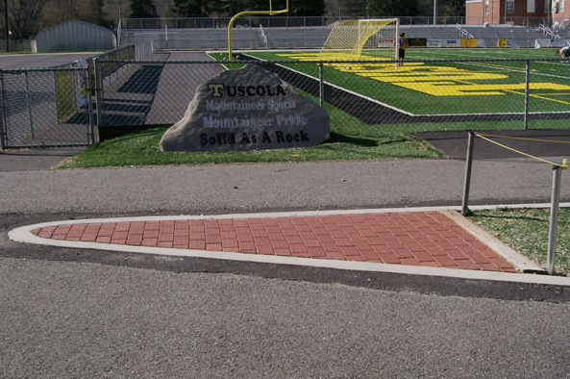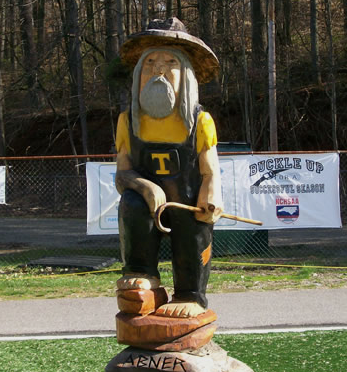

Donations
You are aware, no doubt, of our nation’s financial crisis and its impact on public schools. Our faith-based community coordinated a Volunteer Workday in August, and the Haywood County Schools Foundation raised $47,000 through their Save-A-Teacher campaign. How can you help? Make a donation payable to Tuscola High School with how you want the money designated in the subject line of your check. Address the envelope to the attention of Pat Wyatt, who will send you a receipt for tax purposes. All gifts, large and small, will be appreciated.

2008-09 Retirees
We want to wish the following persons much happiness as they begin a new chapter in their lives. Each of them has impacted us in ways that they will never know. Although they are gone from “The Hill”, their legacy will forever remain.

Charles Howard
Math Teacher

Susan Kingshill
English Teacher
Jim McClure
Custodian

Tinga Medford
Math Teacher

Email hallen@haywood.k12.nc.us if you have any memories or appreciative words for these folks, and I will make sure that they get them. Please include your maiden name and the year(s) you were in her/his class.

Home, Again
Alumni on Staff at THS

1969 Karen Nichols Sutton
1970 Pat Edwards Mills
1971 Gay Askins Phillips
1971 Paula Gaddis Sheets-Price
1972 Mary Ann Miller Smith
1973 JoAnn Hickman Grasty
1973 Rena Wyatt
1974 Sharon Wyatt Rathbone
1975 Lt. Col. Robert Brown
1976 Darlene Birchfield Lowe
1976 Sandy Pruett Myers
1977 Betsy Farrow Gunter
1977 Debbie Garrett Hill
1978 Mike Sutton
1979 Robin West Rogers
1980 Jim Davis
1980 Missy Ray Gentry
1980 Barbara Teague Fowler
1981 Cindy Cogdill Early
1981 Vicky Evans Messer
1982 Lisa Birchfield Burgin
1984 Sherry Henson Banks
1985 Dawn Rathbone Jones
1986 Becky Edwards Revis
1987 Jason Heinz
1988 Julia Plott Rich
1988 Troy Rich
1990 Wendy Davis Rogers
1995 Barron Rogers
1996 Heather Allen
1996 Cecilia Ruth Lance Marcus
1996 Courtenay Roberson McElroy
1996 Adam Perry
1996 Eric Sollie
1997 Maggie Boone Melville
1997 Joy Wadsworth Sollie
1998 Aaron Owenby
1998 Beth Sanderson
1999 Cameron Kingshill
2001 Beth Dixson Ross
2002 Melanie Galliers
2005 Brian Franklin

New Website
By receiving this e-newsletter, you probably have visited our new website already and shared your contact information with us. If not, click on the Alumni tab to be added to our mailing list. Check back often to stay informed.
http://www.ths.haywood.k12.nc.us/
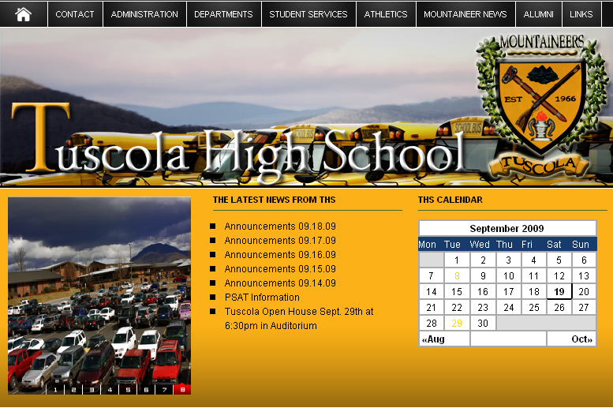

MOUNTAINEER CALENDAR OF EVENTS

Varsity sports only included.
Final scores can be found at http://www.highschoolsports.net and http://www.tuscolafootball.com.
Non-sporting events are highlighted in gray.

SEPTEMBER 2009
Monday, September 21
3:00 p.m. - Golf versus Mountain Heritage (Away)
4:00 p.m. - Tennis versus Smoky Mountain (Away)
7:00 p.m. - Soccer versus North Henderson (Home)

Tuesday, September 22
4:00 p.m. - Tennis versus West Henderson (Away)
6:30 p.m. - Volleyball versus East Henderson (Away)

Wednesday, September 23
4:00 p.m. - Tennis versus Brevard (Home)
8:00 p.m. - Soccer versus Pisgah (Home)

Thursday, September 24
TBA - Cross Country versus Brevard (Away)
3:00 p.m. - Golf versus Charles D. Owen (Away)
6:30 p.m. - Volleyball versus Franklin (Home)

Friday, September 25
7:30 p.m. - Football versus Smoky Mountain (Home)

Monday, September 28
3:00 p.m. - Golf versus North Henderson (Away)
4:00 p.m. - Tennis versus North Henderson (Away)
6:30 p.m. - Volleyball versus North Buncombe (Home)
7:00 p.m. - Soccer versus West Henderson (Away)

Tuesday, September 29
6:30 p.m. - Volleyball versus Smoky Mountain (Away)

Wednesday, September 30
4:00 p.m. - Tennis versus Pisgah (Away)
7:00 p.m. - Soccer versus East Henderson (Away)

OCTOBER 2009
Thursday, October 1
TBA - Cross Country versus Franklin (Away)
3:00 p.m. - Golf versus Enka (Home)
6:30 p.m. - Volleyball versus Brevard (Home)

Friday, October 2
7:30 p.m. - Football versus Brevard (Away)

Monday, October 5
4:00 p.m. - Tennis versus West Henderson (Home)
7:00 p.m. - Soccer versus Franklin (Home)

Tuesday, October 6
6:30 p.m. - Volleyball versus North Henderson (Away)

Wednesday, October 7
4:00 p.m. - Tennis versus East Henderson (Home)
7:00 p.m. - Soccer versus Smoky Mountain (Away)

Thursday, October 8
TBA - Cross Country v Clyde A. Erwin (Away)
3:00 p.m. - Golf versus TC Roberson (Away)
6:30 p.m. - Volleyball versus Pisgah (Away)

Friday, October 9
7:30 p.m. - Football versus North Henderson (Home)
*Homecoming*

Monday, October 12
4:00 p.m. - Tennis versus Franklin (Away)
8:00 p.m. - Soccer versus Brevard (Home)

Tuesday, October 13
6:30 p.m. - Volleyball versus West Henderson (Home)

Wednesday, October 14
7:00 p.m. - Soccer versus North Henderson (Away)

Thursday, October 15
TBA - Cross Country versus Enka (Away)
6:30 p.m. - Volleyball versus East Henderson (Home)

Friday, October 16
7:30 p.m. - Football versus Pisgah (Home)
*1st Alumni Event*

Monday, October 19
7:00 p.m. - Soccer versus Pisgah (Away)

Tuesday, October 20
6:30 p.m. - Volleyball versus Franklin (Away)

Wednesday, October 21
7:00 p.m. - Soccer versus West Henderson (Home)

Friday, October 23
7:30 p.m. - Football versus West Henderson (Away)

Saturday, October 24
TBA - Cross Country versus Asheville (Away)

Monday, October 26
7:00 p.m. - Soccer versus East Henderson (Home)

Wednesday, October 28
7:00 p.m. - Soccer versus Franklin (Away)

Friday, October 30
7:30 p.m. - Football versus East Henderson (Away)

NOVEMBER 2009
Friday, November 6
7:30 p.m. - Football versus Franklin (Home)

Wednesday, November 18
5:30 p.m. - Swimming versus Franklin (Home)

Thursday, November 19
6:30 p.m. - Basketball versus Clyde A. Erwin (Home)

Friday, November 20
6:00 p.m. - Wrestling versus Mitchell (Home)

Saturday, November 21
9:30 a.m. - Swimming at Murphy

Saturday, November 21 – Sunday, November 22
Chamber Choir’s Broadway Show at THS

Tuesday, November 24
5:00 p.m. - Wrestling at West Henderson
6:30 p.m. - Basketball versus Cherokee (Away)

Saturday, November 28
6:30 p.m. - Basketball versus North Buncombe (Home)

DECEMBER 2009
Wednesday, December 2
3:30 p.m. - Swimming at Asheville School
6:30 p.m. - Basketball versus North Buncombe (Away)

Friday, December 4
5:00 p.m. - Wrestling at West Henderson
6:30 p.m. - Basketball versus Clyde A. Erwin (Away)

Saturday, December 5
5:00 p.m. - Wrestling at West Henderson
Monday, December 7
Holiday Chorus Concert at First United Methodist Church

Tuesday, December 8
6:00 p.m. - Wrestling at Franklin
6:30 p.m. - Basketball versus Enka (Away)

Wednesday, December 9
5:30 p.m. - Swimming versus North Henderson (Home)

Thursday, December 10 – Monday, December 14
Marching Band, Chamber Choir, and Summit perform
at Walt Disney World

Friday, December 11
6:30 p.m. - Basketball versus Smoky Mountain (Home)

Saturday, December 12
9:30 a.m. - Wrestling (Home)

Tuesday, December 15
6:30 p.m. - Basketball versus Brevard (Away)

Wednesday, December 16
6:30 p.m. - Basketball versus Rabun Gap (Home)

Friday, December 18
5:00 p.m. - Swimming at Hendersonville YMCA
6:30 p.m. - Basketball versus North Henderson (Home)

Saturday, December 19
TBA - Swimming at Ironman Zeugner Center
9:30 a.m. - Wrestling at West Lincoln

Tuesday, December 22
1:00 p.m. - Wrestling at Charles D. Owen
6:30 p.m. - Basketball versus Enka (Home)

Wednesday, December 23
1:00 p.m. - Wrestling at Charles D. Owen



The Alumni e-Newsletter will be published three times each year in September, December, and March. To update your personal information, share news, or offer feedback, please email Heather Allen at hallen@haywood.k12.nc.us or write/call me at the address, phone, or fax number below.
Tuscola High School, 564 Tuscola School Road,Waynesville, NC 28786
(828) 456-2408 phone (828) 456-2434 fax

