**FBLA MEMBERS PLACE AT WESTERN REGION COMPETITIVE EVENTS**

On Tuesday, December 3, 2013, six FBLA members from Tuscola High School traveled to North Buncombe High School to participate in the Western Region Competitive Events.

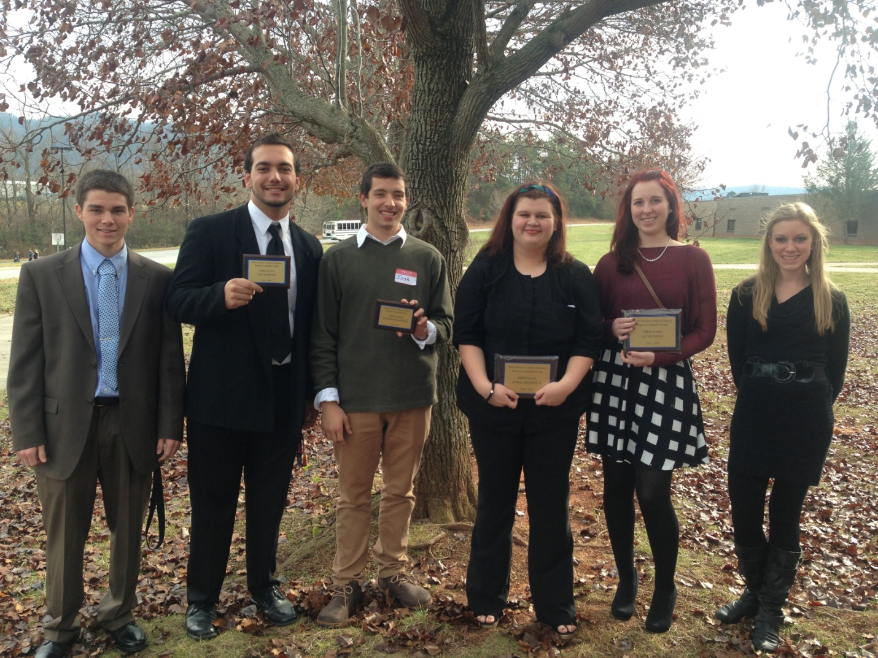From left to right

Vincent Lubinski – participated in Word Processing

Zach Lennane – placed 3rd in Job Interview

Josh Horner – placed 3rd in Business Procedures

Salina Dickie – placed 1st in Public Speaking II

Bailey Butters – placed 1st in Accounting I

Rebecca Howell – placed 1st in Business Calculations

Future Business Leaders of America (FBLA) is a Career and Technical student organization where students are given further opportunity to develop character, citizenship, technical, leadership, and teamwork skills essential for those preparing for the workforce and further education.