**FBLA DONATES TO OPERATION**

**CHRISTMAS CHILD**

For the second year in a row, members of the Tuscola FBLA (Future Business Leaders of America) club chose “Operation Christmas Child” as their community service project. *(Operation Christmas Child began in 1993 and provides shoeboxes for children in desperate situations around the world packed with items such as school supplies, toys, hygiene items, etc.).* Through fundraising efforts, members raised enough money to purchase items for six shoeboxes.

From left to right:

Amanda Guest, Faith McElroy, Savannah Johnson, Levi Birchfield. Missing from picture: Rebecca Howell

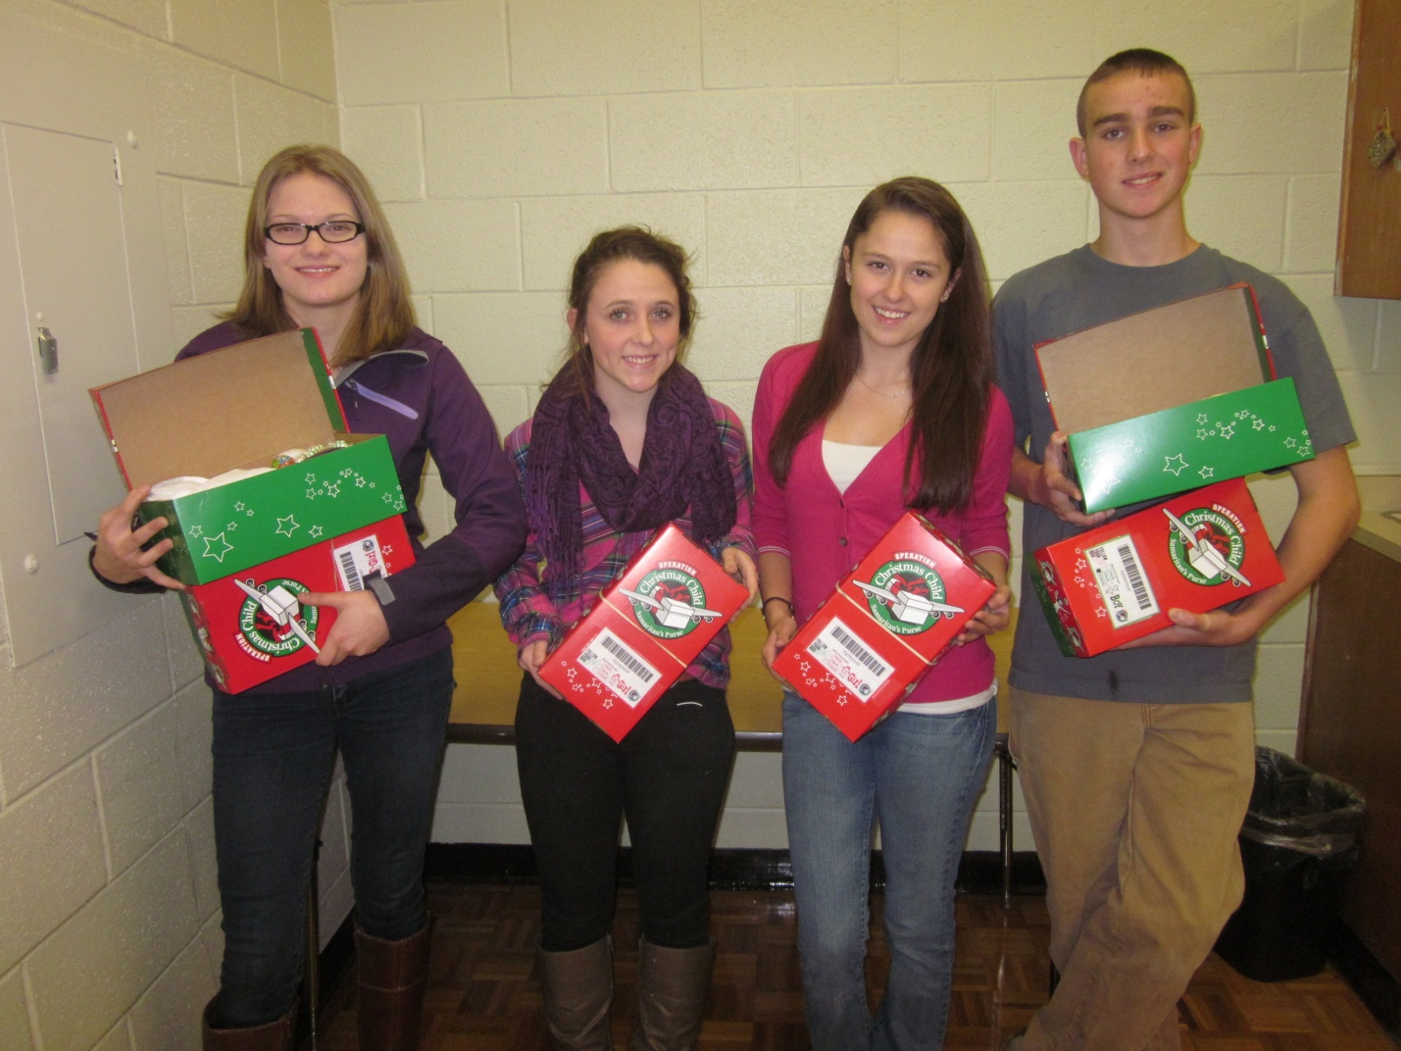

Future Business Leaders of America (FBLA) is a Career and Technical student organization where students are given further opportunity to develop character, citizenship, technical, leadership, and teamwork skills essential for those preparing for the workforce and further education.