1st GRADE SUPPLY LIST

RIVERBEND ELEMENTARY 2022-2023

Student List

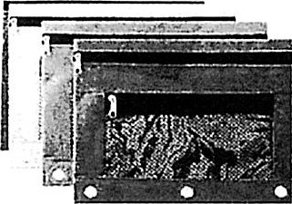(write your child's name on these supplies)

Headphones (must last all year)

Water Bottle

1 mesh pencil pouch (3 ring binder type, see photo)

Classroom Supplies

(these will be collected and distributed to the class as needed)

$5 Student Consumables Fee

I primary composition notebook (half page lined with blank space above, see example in photo)

2 plastic pronged folders with pockets (blue, green)

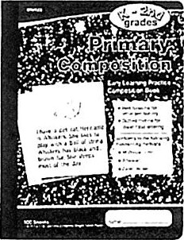2 packs of pencils (suggest Ticonderoga)

I pack of colored pencils

8 glue sticks

Fine-tip dry erase low odor markers

# Donations Appreciated

Tissues & Ziplock Bags

As we strive to maintain a safe learning environment, rolling backpacks are not permitted.

Supply lists are a result of parent requests year after year. We want our families to know, however, that we will provide each and every Riverbend student everything they need. We thank our community for their support, generosity, and their love to start each new academic year excited about our school!