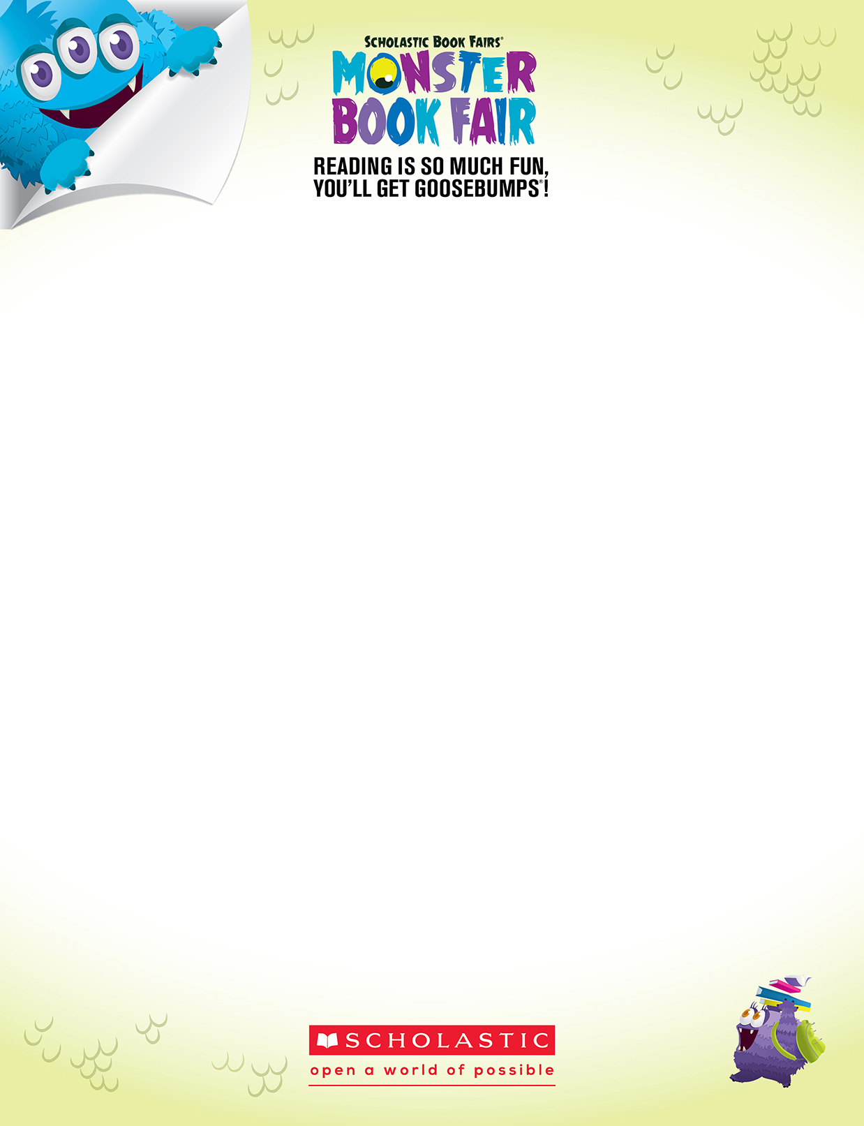
Dear Parents and Families,
© 2015 Scholastic Inc. 12474 • 161201

Permission to reproduce this item is granted by Scholastic Book Fairs®.

The Scholastic Book Fair will be at our school October 6th-9th and special Family Events are scheduled for Tuesday Oct. 6th 3:00-5:30pm & Oct. 8th 7:20-8:10am.

Our new Book Fair theme for fall 2015 is Monster Book Fair: Reading is So Much Fun You’ll Get GOOSEBUMPS! This season’s Book Fair will be an exciting celebration full of fun activities and hundreds of books kids want to read.

If you have some time to help us plan or conduct our Book Fair, please complete the form below and circle the areas where you would like to help. Return the form to Mrs. Barker in Media Center.

Sincerely,

Nikki Barker
Book Fair Chairperson

Sign me up to help at the Book Fair!

Name Telephone
Email

I have circled areas where I’d like to help:
• Unloading Boxes • Serving refreshments at Family Night Event • Setting up the Fair • Pass out tickets at Family Night Event

