  BEHAVIOR  EXPECTATIONS | Hallway | Cafeteria | Restroom | Bus | Playground | Dismissal | Classroom
 | 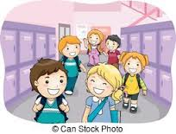 |  | 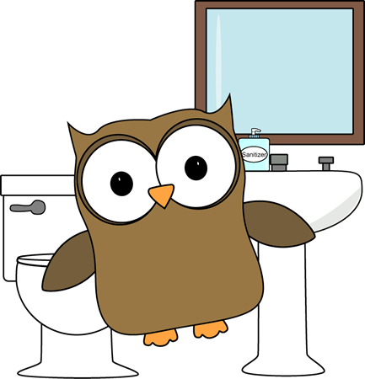 | 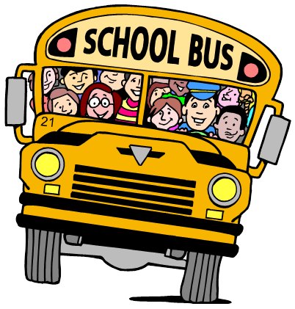 | 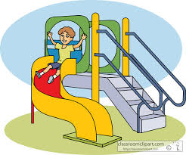 | 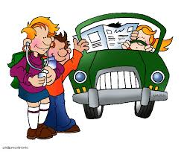 | 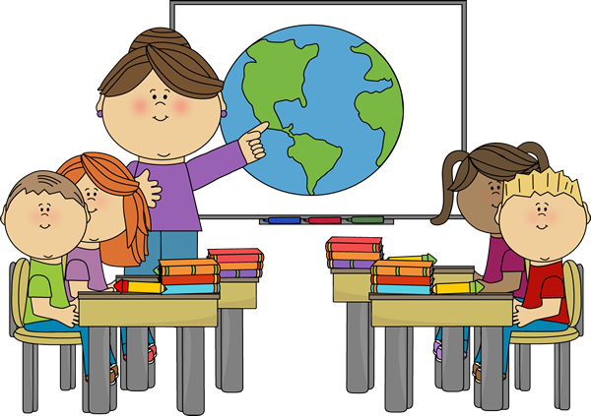
Be  Respectful | Keep hands, feet, and objects to yourself.  Always walk on the right-hand side. | Keep hands, feet, and objects to yourself.  Stand quietly in line and wait your turn.  Greet and thank the cafeteria staff. | Keep hands, feet, and objects to yourself.  Maintain and respect privacy of yourself and others.  No talking.  Wait your turn patiently. | Keep hands, feet, and objects to yourself and inside the bus.  Remain seated at all times.  Get on and off the bus one at a time.  Use inside voices for appropriate conversations. | Keep hands, feet, and objects to yourself.  Play fairly and include everyone.  Be a good sport whether you win or lose. | Keep hands, feet, and objects to yourself.  Listen silently to announcements.  Walk quietly down the hall.  Exit in an orderly fashion. | Keep hands, feet, and objects to yourself.  Use kind words and actions with peers.  Raise hand to speak and listen to others when they are speaking.
Be Responsible | Walk with Panther pride.  Go straight to your destination. | Make healthy food choices.  Use good table manners.  Clean up after yourself.  Use inside voices for appropriate conversations. | Wash your hands with soap and water.  Flush.  Report any problems immediately to your teacher. | Follow ALL bus rules.  Keep aisles clear.  Keep all of your belongings in your book bag. | Play for fun and accept differences.  Use appropriate language, facial expressions, and physical use of body. | Remain patient and polite.  Be sure you have gathered all of your belongings and homework. | Follow directions the first time they are given.  Use time wisely.  Give your best effort and complete all assignments.
Be  Ready | Give each other space.  Walk silently in a  straight line, facing forward. | Follow your classroom dismissal procedures.  When returning trays, empty milk cartons and place silverware in the proper container. | Return to class promptly.  No playing. | Always listen to your bus driver. | Line up quickly when called.  Use equipment correctly. | Load the bus quickly and quietly.  Sit quietly in car line, and listen for your name to be called. | Be on time and prepared with books, supplies, and schoolwork every day.  Take care of materials.

