PISGAH HIGH SCHOOL
2013-2014 Dress Code

 | Females |  |  | Males
Types of  Clothing |  | APPROPRIATE | NOT APPROPRIATE | APPROPRIATE | NOT APPROPRIATE
Shirts  Guidelines should fall in this range:  Necklines of shirts, blouses and dresses should show no cleavage. Straps of tank tops must be the width of one inch. Tank & Muscle tops must cover underarms and side of chest areas. No tube or halter tops. Shirts cannot be see-through. |  | 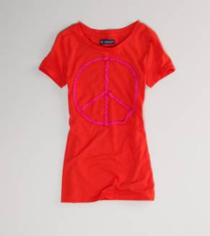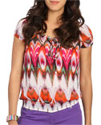 | 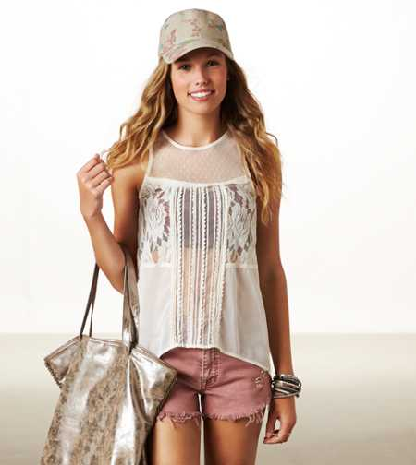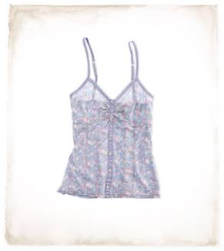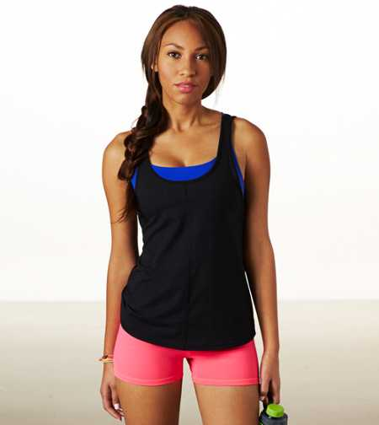 | 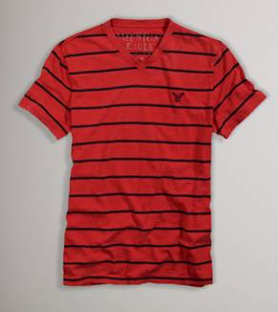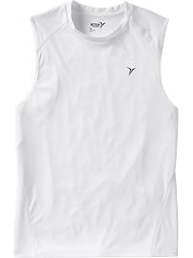  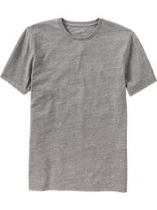 | 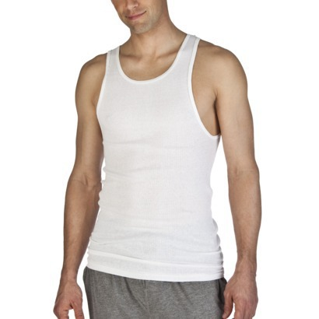
Types of  Clothing |  | APPROPRIATE | NOT APPROPRIATE | APPROPRIATE | NOT APPROPRIATE
Dresses / Skirts/ Shorts  The top of all dresses follow the same directives as shirts.  Finger tip length is required. |  | 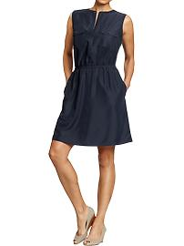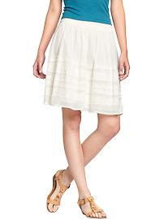 | 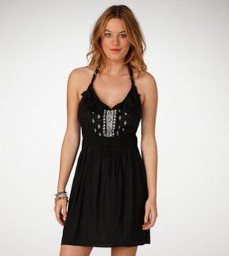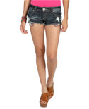 | 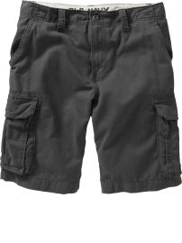 | 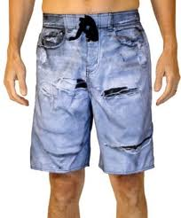
Pants  Pants may only have open holes at or below finger tip length.  Undergarments must not be visible. Pants are to be worn at the waist (no sagging pants).  Leggings are not pants. Tops must be finger length. |  | 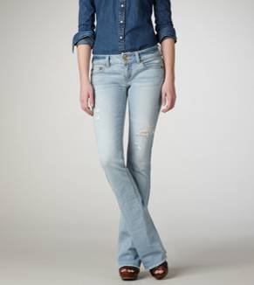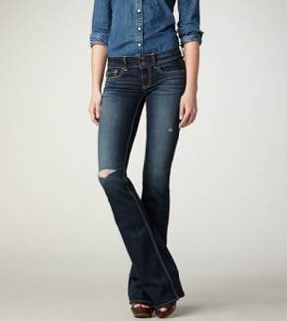 | 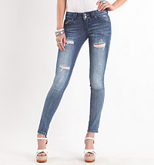 | 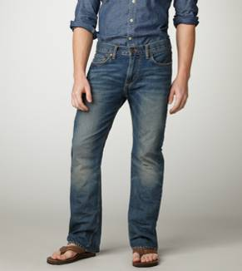 | 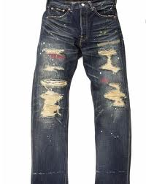
Images from American Eagle, Wet Seal, Old Navy, and Alki
Other Dress Code Guidelines can be found in the PHS Student Handbook:
• Clothing should completely cover all undergarments.
• Clothing cannot have logos or symbols which refer to, or promote, tobacco, drugs, alcohol, violence, gangs, lewd conduct, or anything of an offensive nature.
• Caps and hats are not allowed inside classrooms, the Media Center, Main Office, Cafeteria, Guidance Office or Auditorium. E building teachers have the discretion to allow caps and hats in the shop and classroom areas.
• Bandannas and kerchiefs are prohibited.
• Hoods should never be worn inside the school buildings or on the school bus.
• Sunglasses are not permitted at any time during the school day inside school buildings unless medically necessary.

