PISGAH HIGH SCHOOL
2012-2013 Dress Code

 | Females |  |  | Males
Types of  Clothing |  | APPROPRIATE | NOT APPROPRIATE | APPROPRIATE | NOT APPROPRIATE
Shirts  Guidelines should fall in this range: necklines of shirts, blouses and dresses should extend no lower than the length of a standard credit card (3 3/8 inch) from the collarbone. Straps of tank tops must be as wide as the length of the card (2 inches). Tank & Muscle tops must cover underarms and side of chest areas. No tube or halter tops. No shirts that  can be seen through. |  | 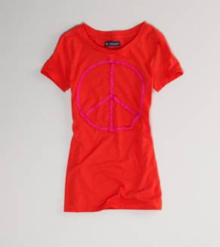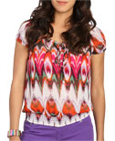 | 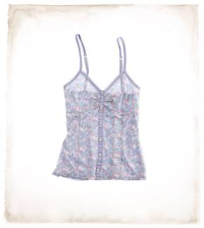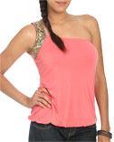 | 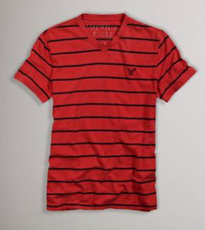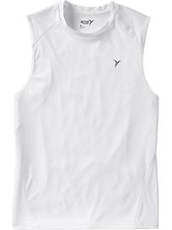  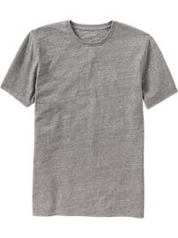 | 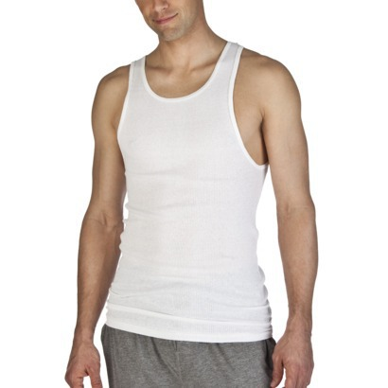
Types of  Clothing |  | APPROPRIATE | NOT APPROPRIATE | APPROPRIATE | NOT APPROPRIATE
Dresses / Skirts/ Shorts  The top of dresses follow the same directives as shirts. Exposed skin above the knee should stay at least 6 ¾” (2 credit card lengths) from the top of the knee. |  | 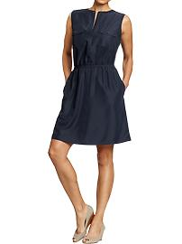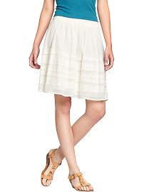 | 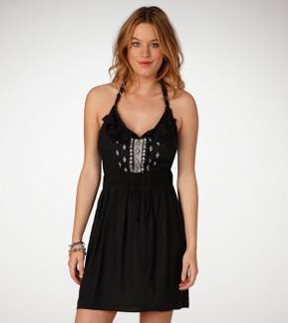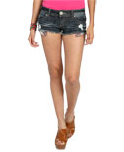 | 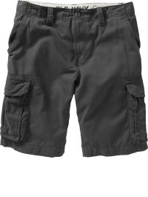 | 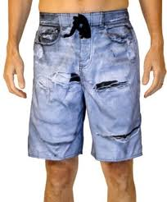
Pants  Pants may only have open holes below 6 ¾” (2 credit card lengths) from the top of the knee. Undergarments must not be visible. Pants are to be worn at the waist (no sagging pants). |  | 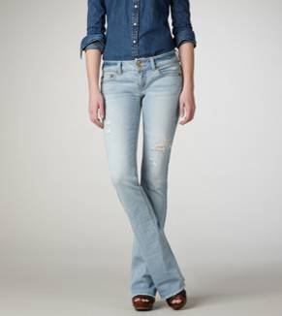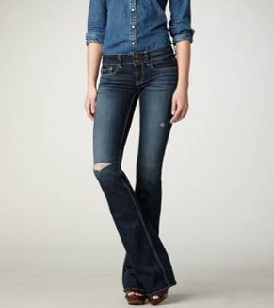 | 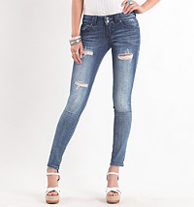 | 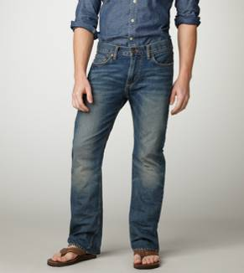 | 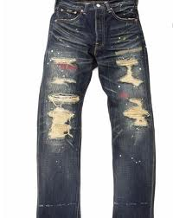
Images from American Eagle, Wet Seal, Old Navy, and Alki

Other Dress Code Guidelines can be found in the PHS Student Handbook:
• Clothing should completely cover all undergarments.
• Clothing cannot have logos or symbols which refer to, or promote, tobacco, drugs, alcohol, violence, gangs, lewd conduct, or anything of an offensive nature.
• Caps and hats are not allowed inside classrooms, the Media Center, Main Office, Cafeteria, Guidance Office or Auditorium. E building teachers have the discretion to allow caps and hats in the shop and classroom areas.
• Bandannas and kerchiefs are prohibited.
• Hoods should never be worn inside the school buildings or on the school bus.
• Sunglasses are not permitted at any time during the school day inside school buildings unless medically necessary.

