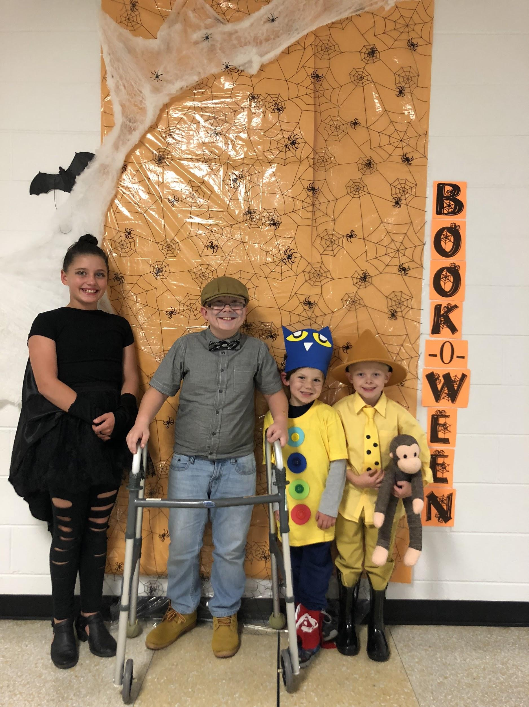

**On October 31, 2018, our school participated in Book-O-Ween. The students and faculty were able to dress up as their favorite book characters. Some even one prizes!**

**(Winners pictured from left to right: Kinsley Snipes as Stellaluna, Grayson Wells as the old man from Maniac McGhee, Brennan Jones as Pete the Cat and Oakley Trull as**

**The Man in the Yellow Hat)**